AZURE DEVOPS ENVIRONMENT SETUP

EXP NO: 1

AIM:
Create Epic, Features, User Stories, Task
To establish and evaluate the process of setting up an Azure DevOps environment by creating a new organization through the Azure portal.
INSTALLATION
- Open a web browser and navigate to:
https://azure.microsoft.com/en-us/get-started/azure-portal.
  - If you have an account:
Sign in using your Microsoft credentials (e.g., Outlook, Hotmail, or Azure AD account).
  - If you don’t have an account:
Create a new Microsoft account at:
https://signup.live.com/?lic=1.

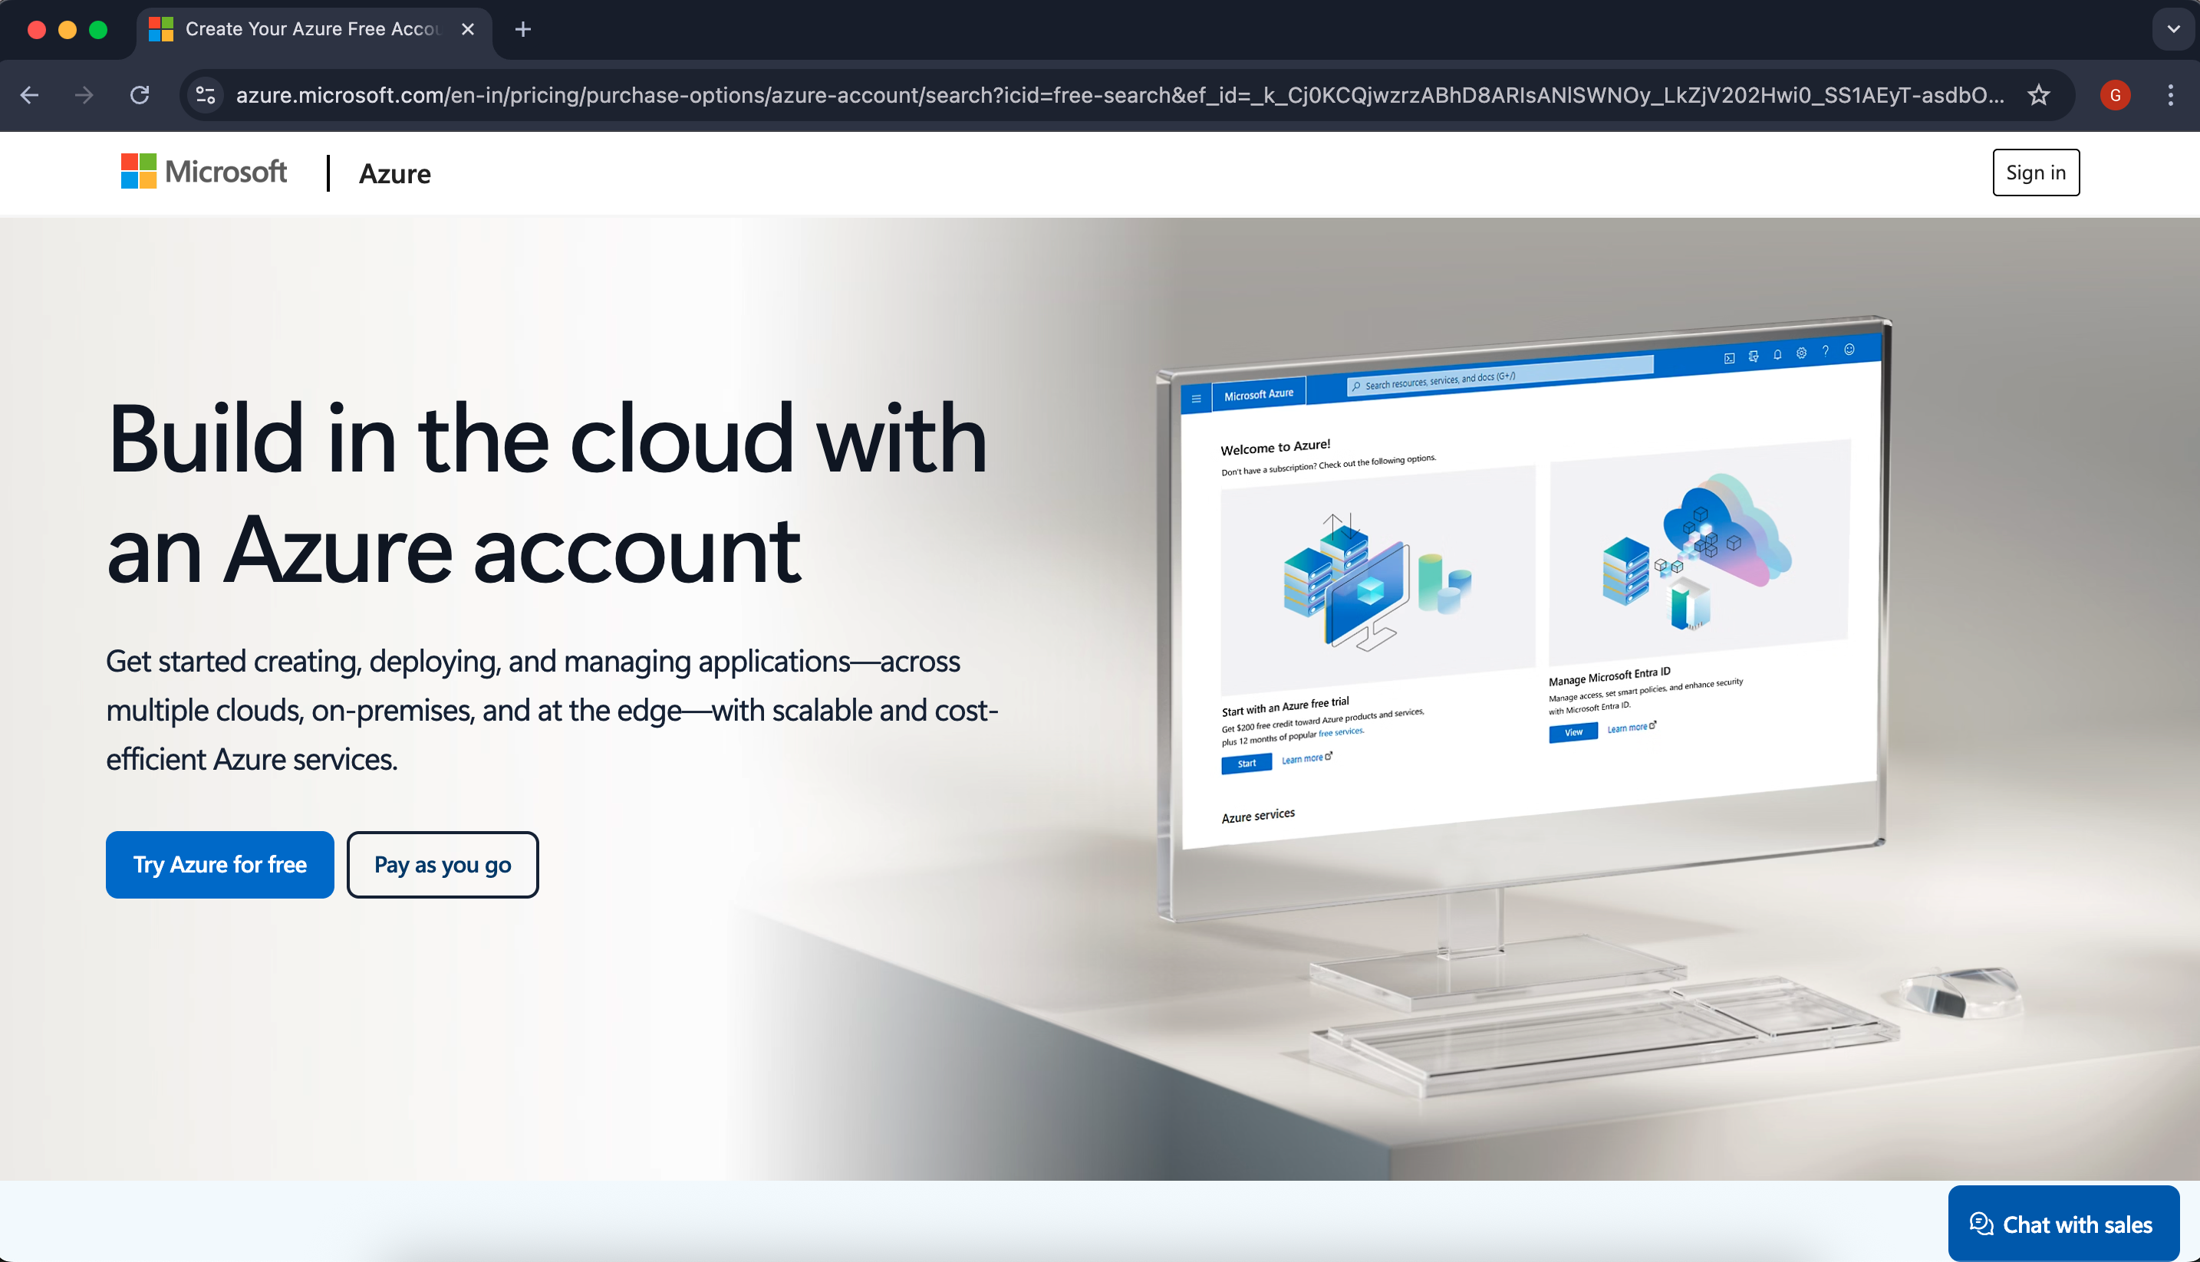
- Azure home page
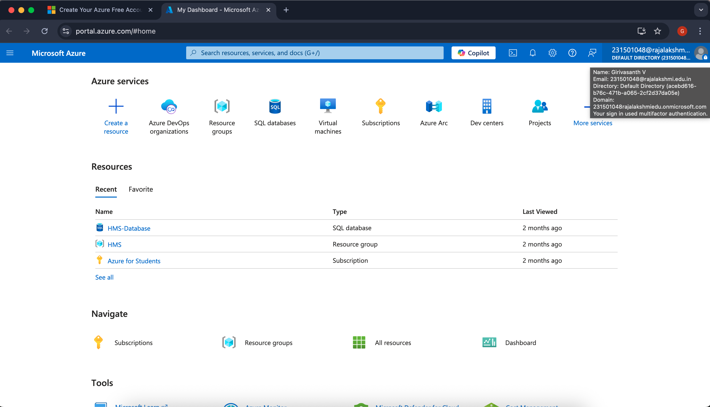

- Search for Azure DevOps Organizations in the Azure portal's search bar and select it to open the DevOps
environment.
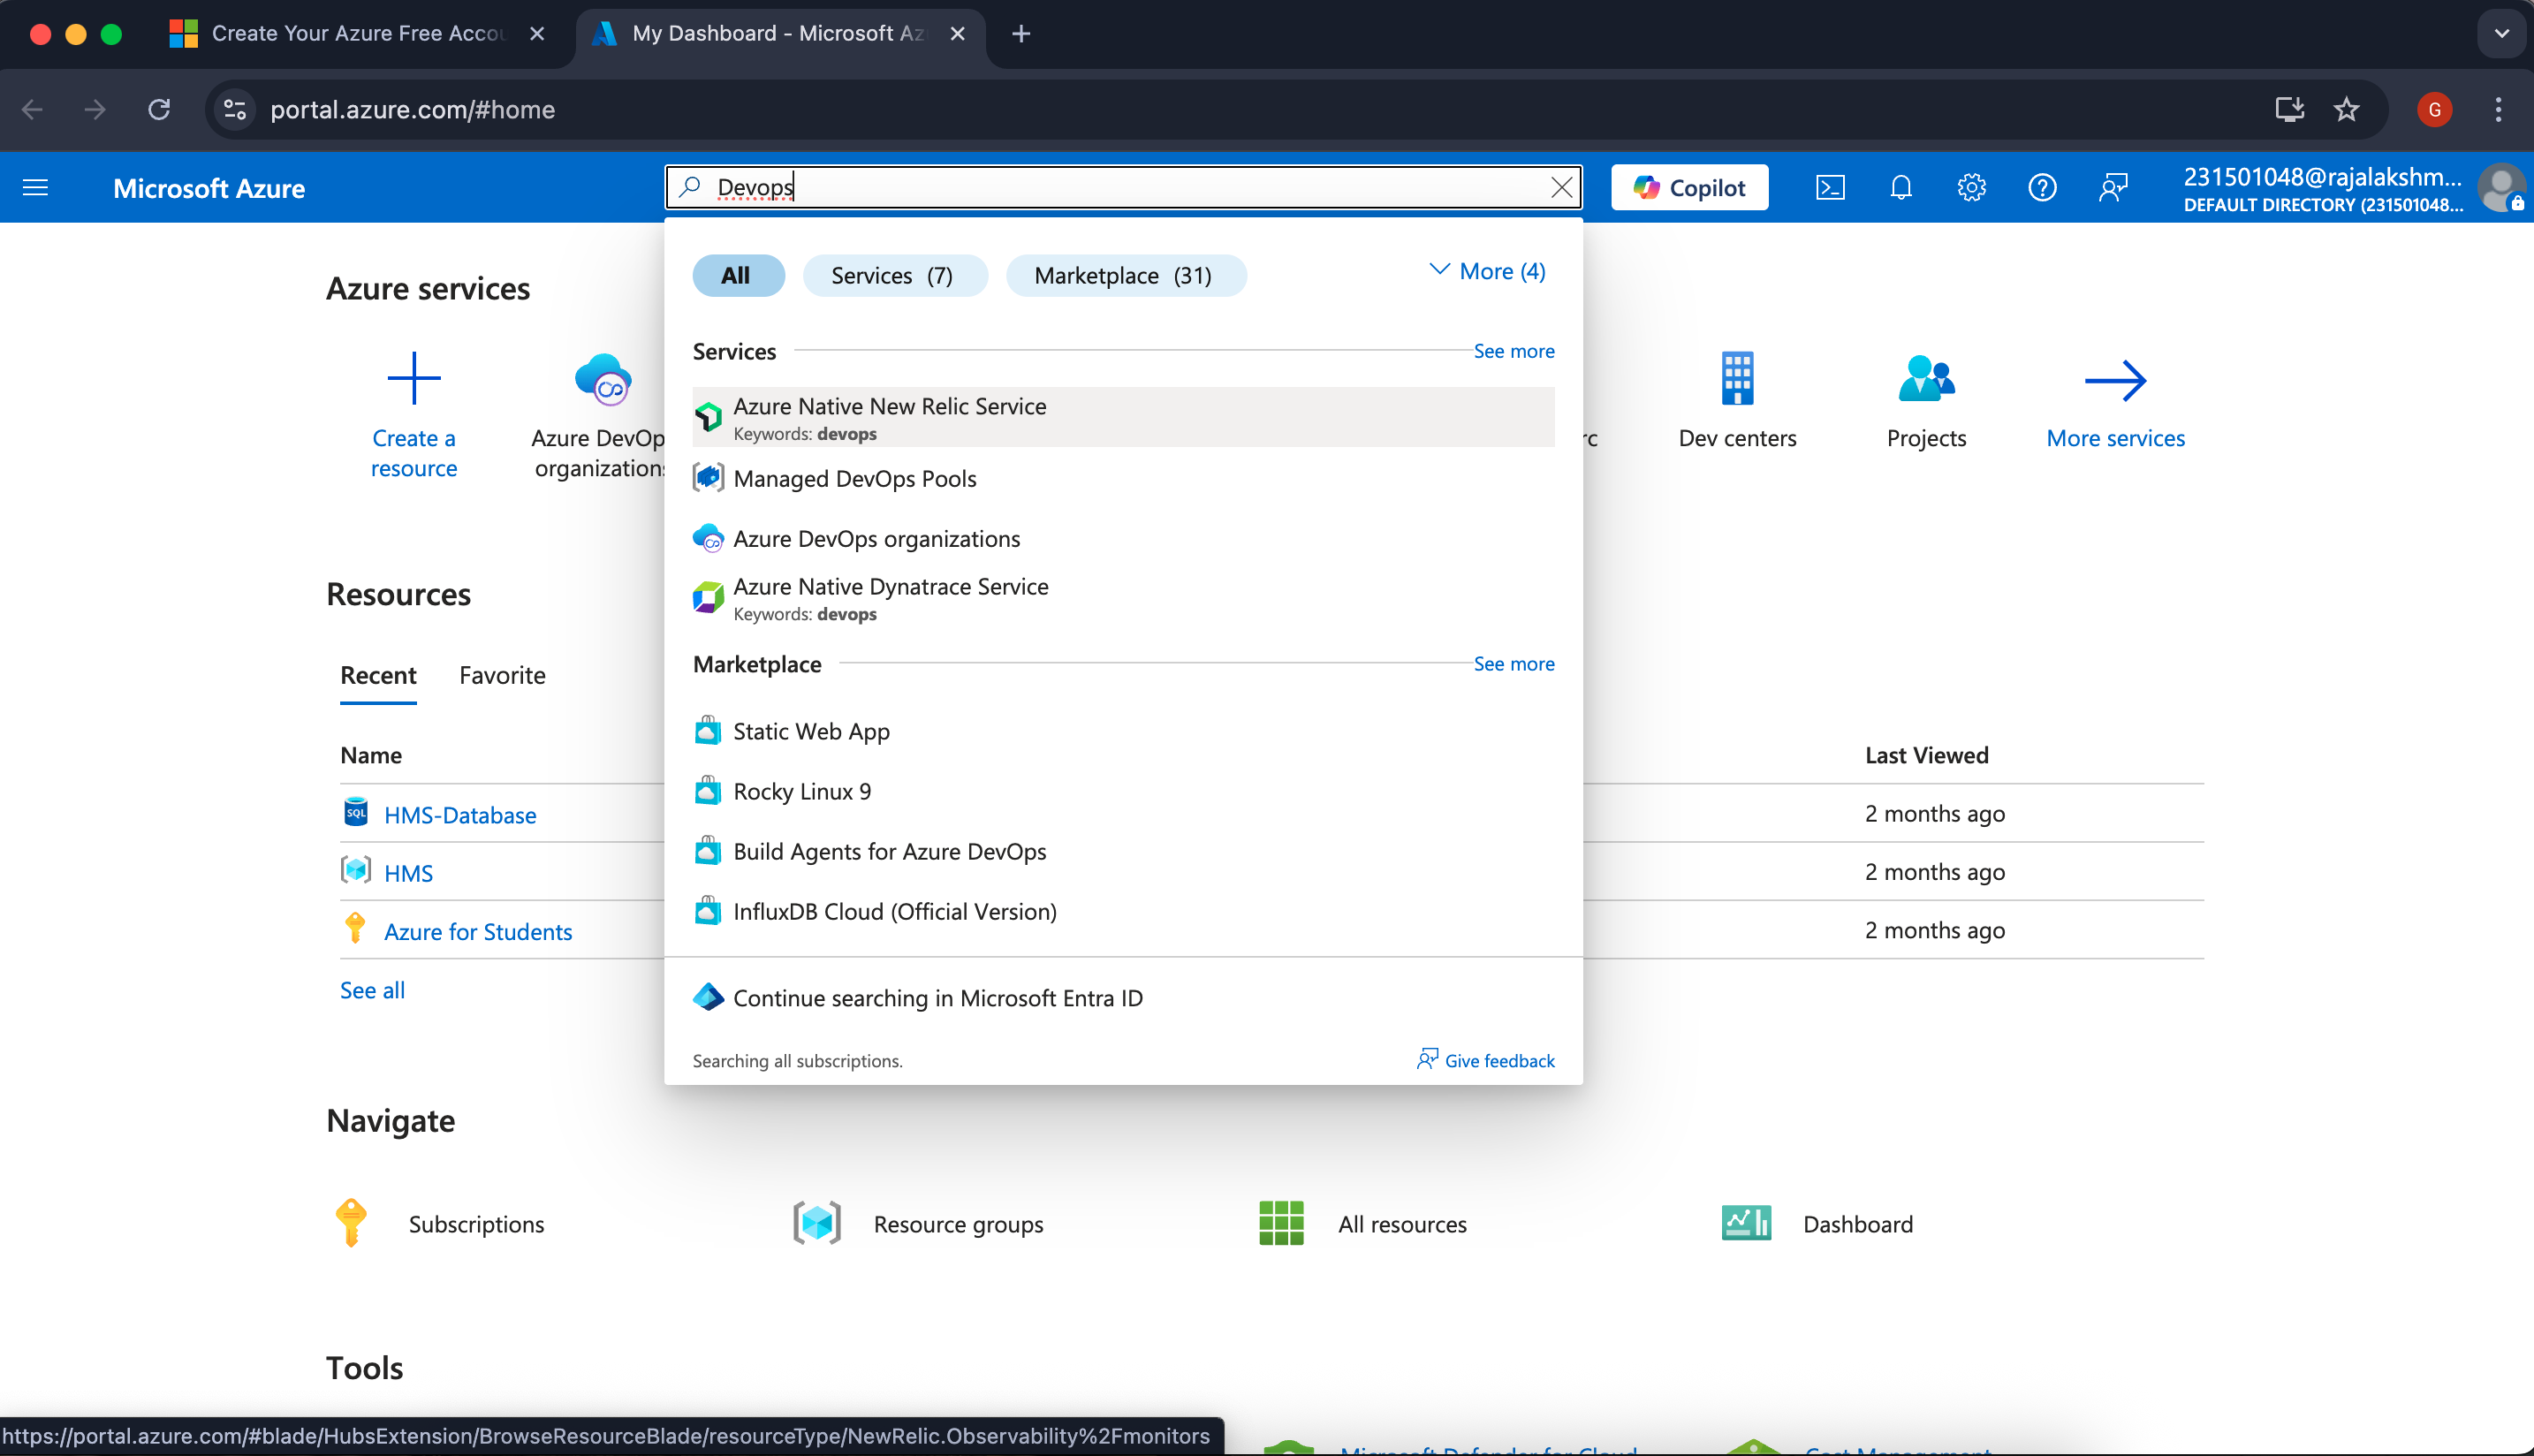
- Click on 'My Azure DevOps Organizations', set up a new organization, and you'll be automatically directed to the Azure DevOps dashboard.
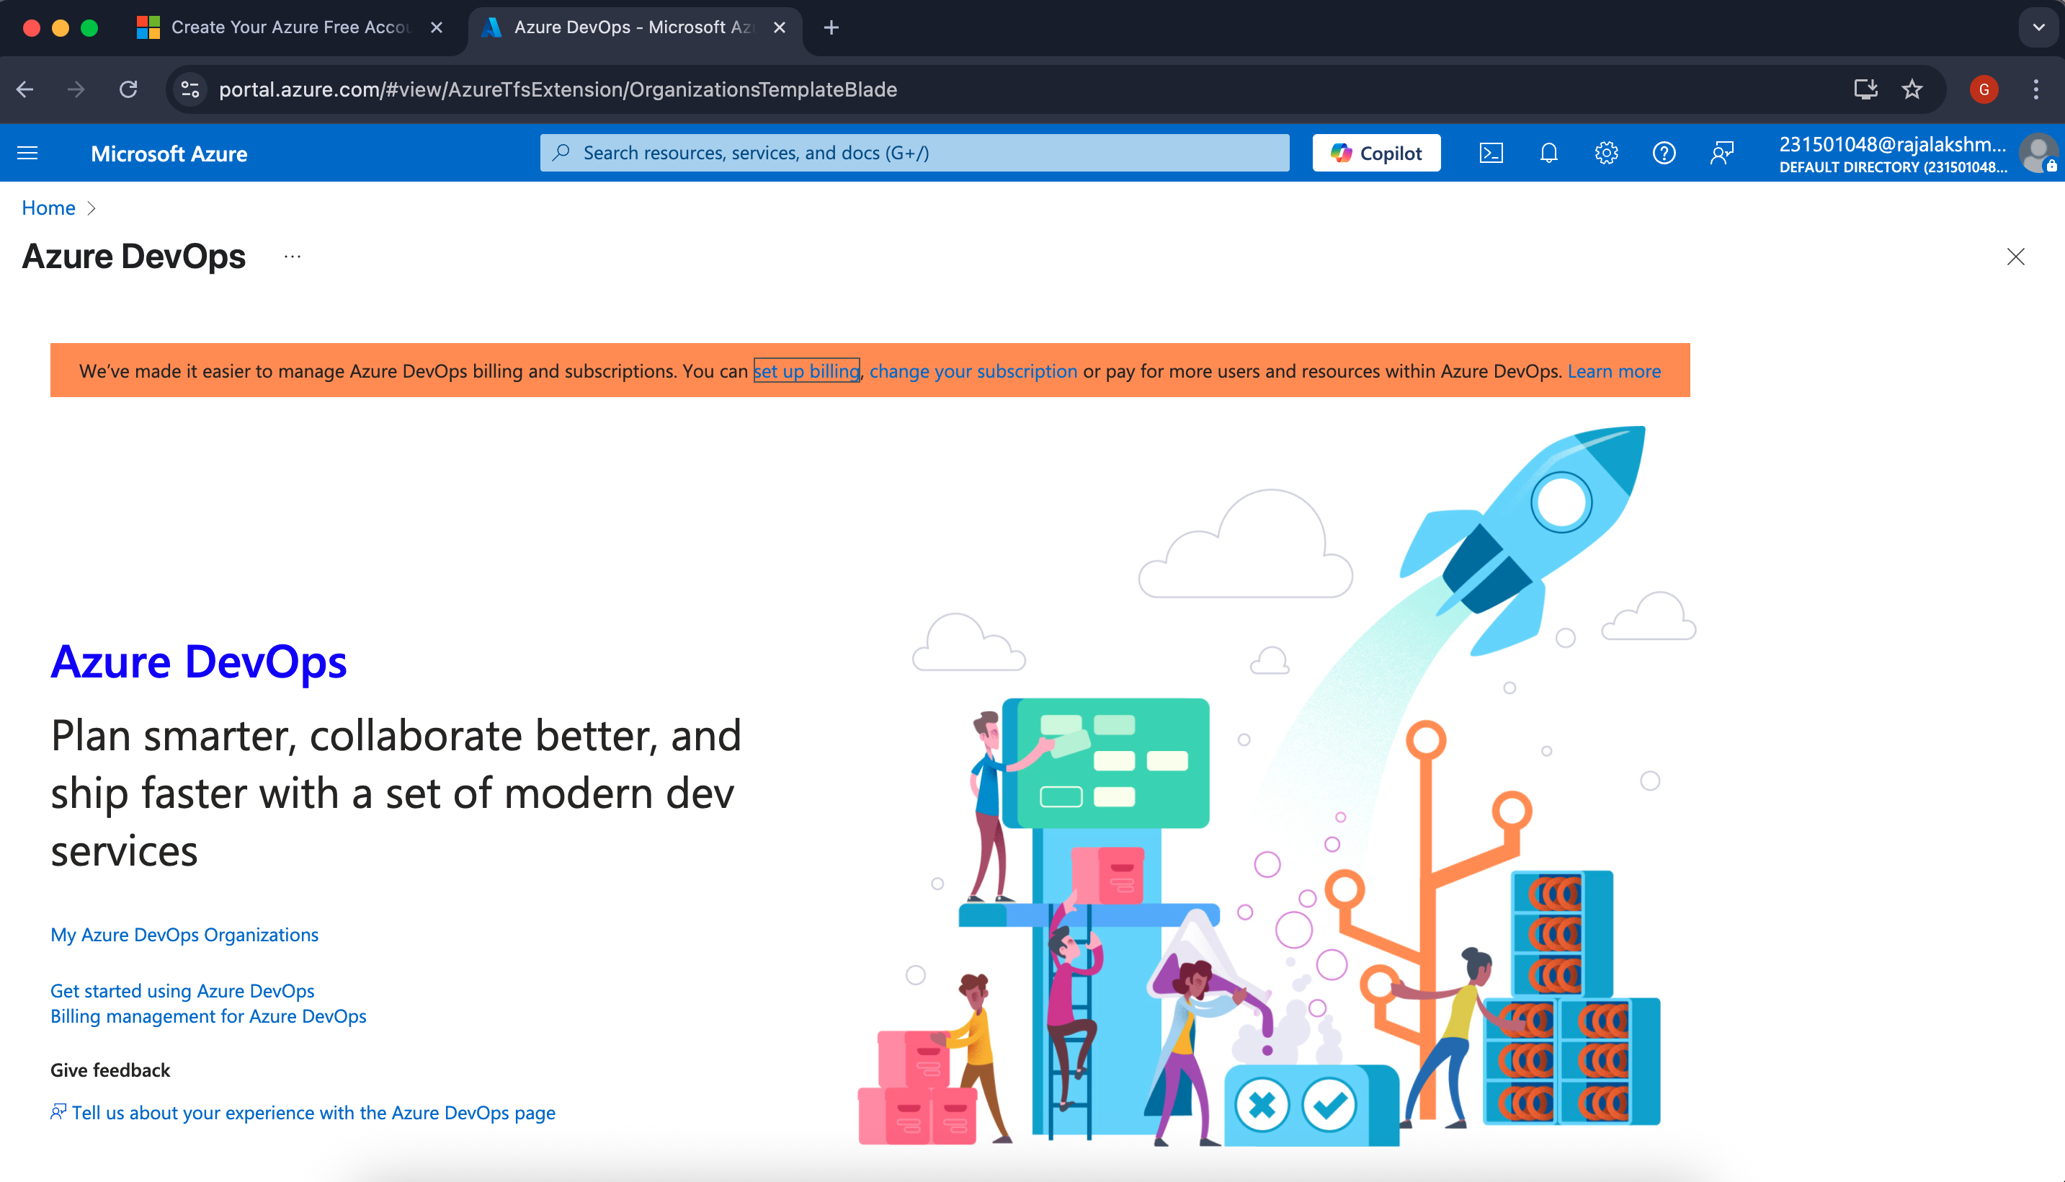

Result:
The Azure DevOps environment was successfully accessed, and a new organization was created via the Azure portal.

AZURE DEVOPS PROJECT SETUP AND USER STORY MANAGEMENT

EXP NO: 2

Aim:
Create Epic, Features, User Stories, Task
To establish an Azure DevOps project that enables streamlined collaboration and effective agile project management.
1.Create An Azure Account

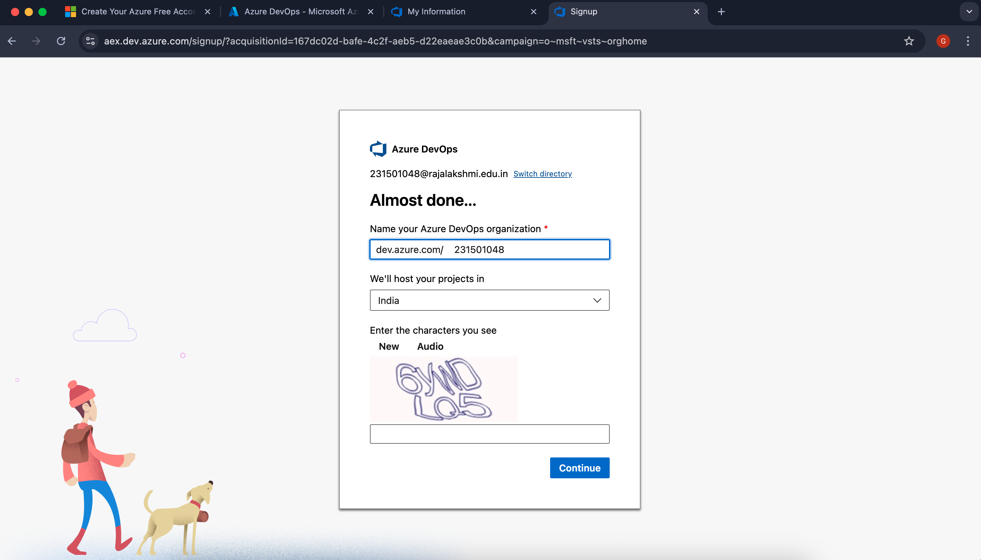

2.Create Your First Project in the Organization
- Initialize Project Setup
Once your organization is established, create your first project to manage code repositories, pipelines, work items, and other development components.
- Access Project Creation
From your organization's homepage, select "New Project" to begin the setup process.
- Configure Project Details
Provide the following information:
  - Name: Assign a descriptive project name (e.g., "LMS").
  - Description (Optional): Add relevant details about the project's purpose.
  - Visibility: Select either:
  - Private (Restricted to invited members)
  - Public (Visible to all users)
- d. Finalize Creation
After entering all required details, click "Create" to complete the project setup.
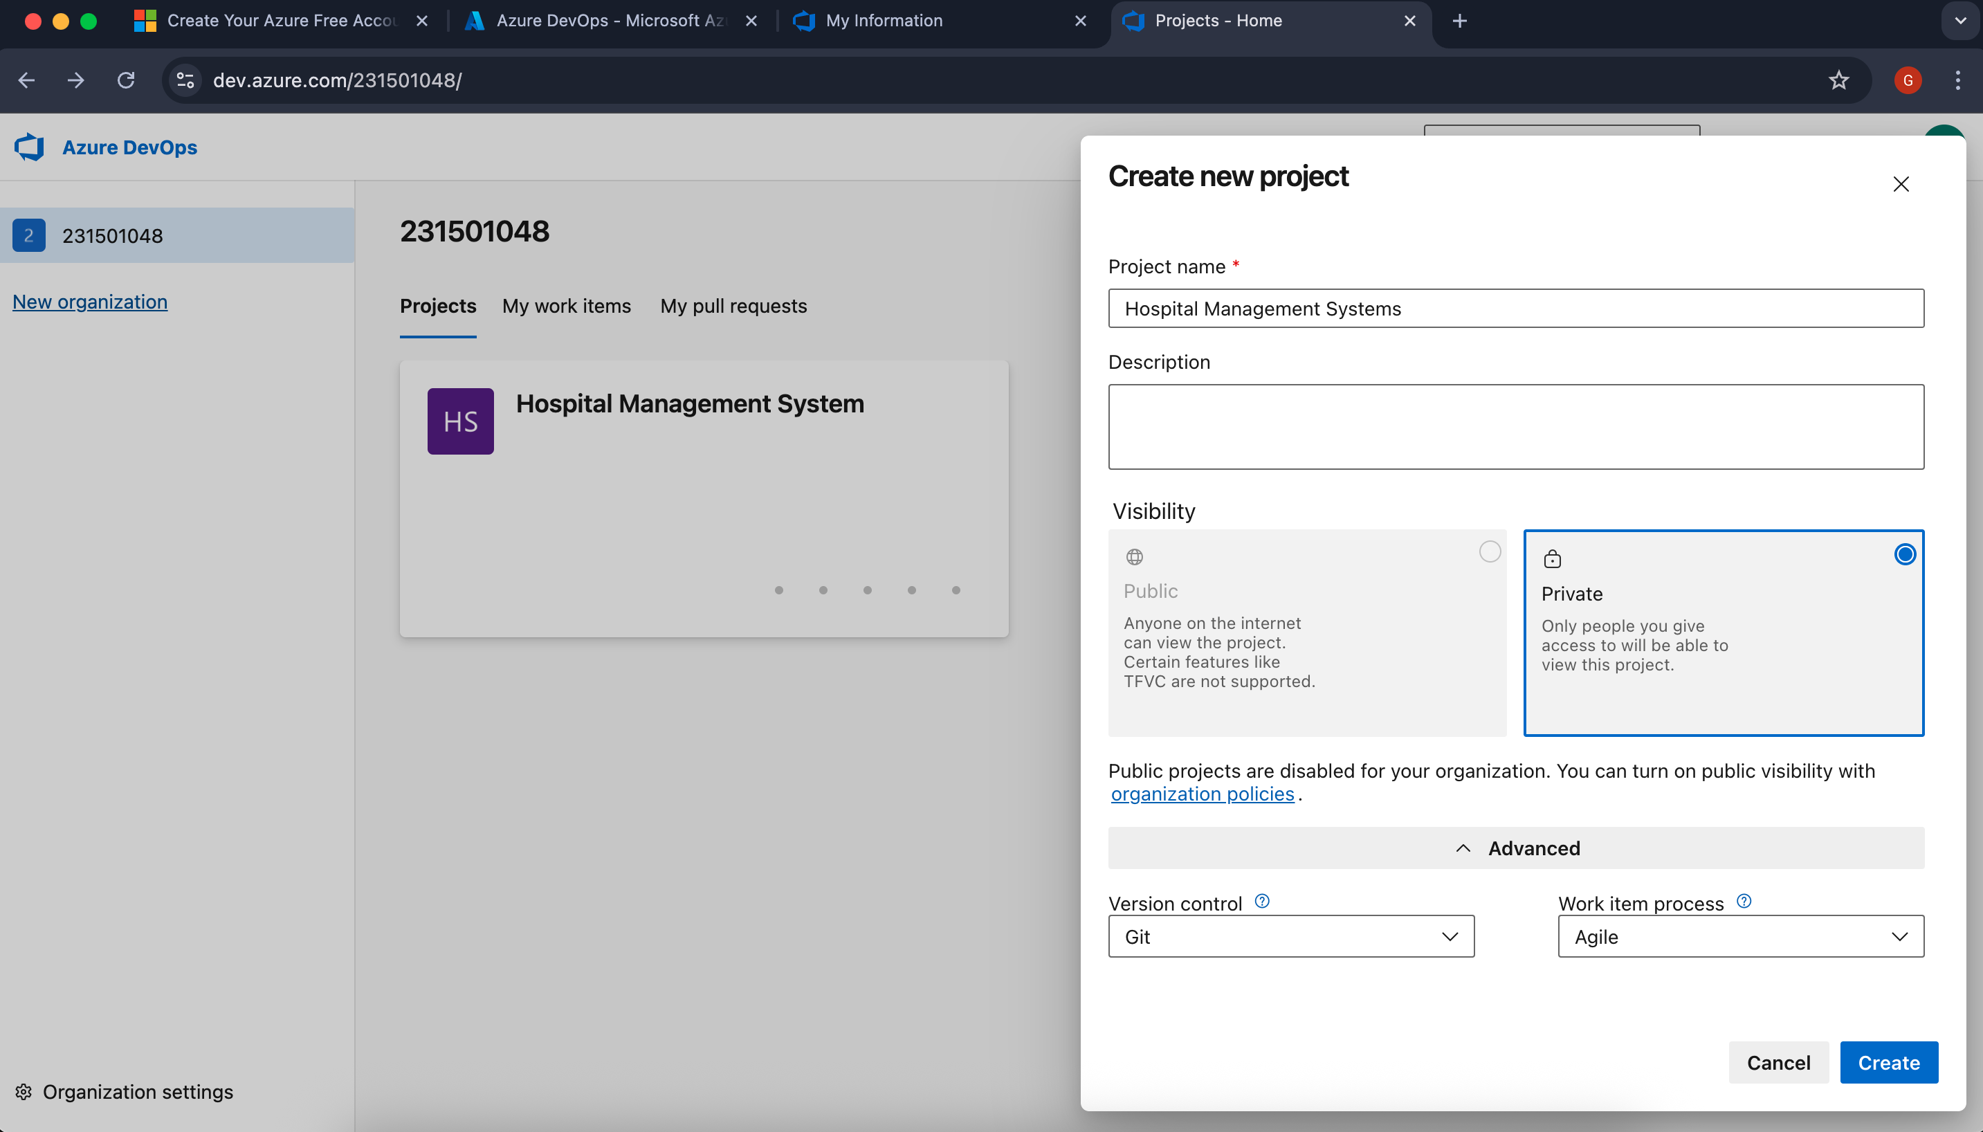

3.After successful login:
- Verify the currently active organization displayed in the top navigation bar
- To change organizations (if you have access to multiple):
  - Locate the organization selector dropdown in the top-left corner (adjacent to your profile icon)
  - Choose your desired organization from the available options
- The system will automatically redirect you to the selected organization's dashboard

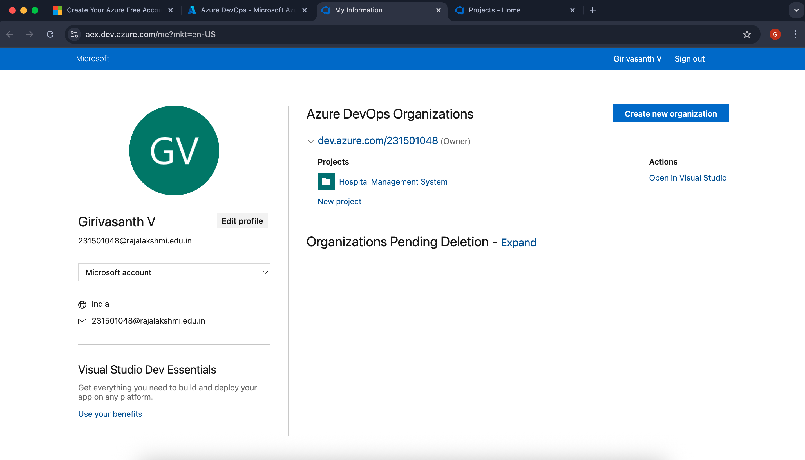

4.Project dashboard

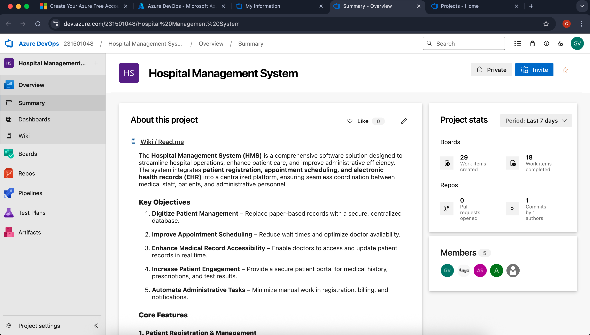
5.Creating and Managing User Stories
a. Access Work Boards
- Navigate to the Boards section using the left-hand menu
- This displays your project's work management interface including backlogs, sprints, and work items
b. Create a New User Story
- Locate the "Add Work Item" control (typically at the top of the page)
- This may appear as:
    - A "+" button
    - An "Add New Work Item" option
    - A dropdown menu
- Select "User Story" from the available work item types
- Complete the form with your story details

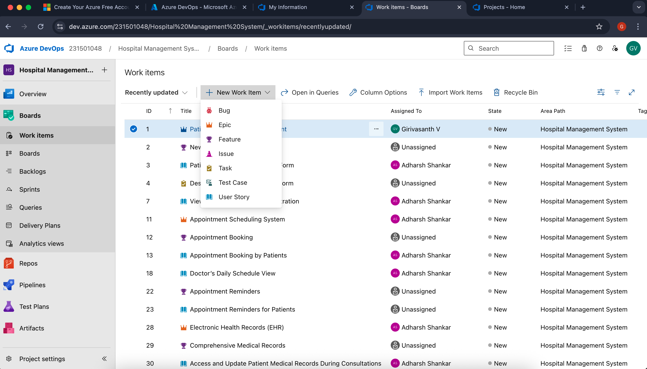

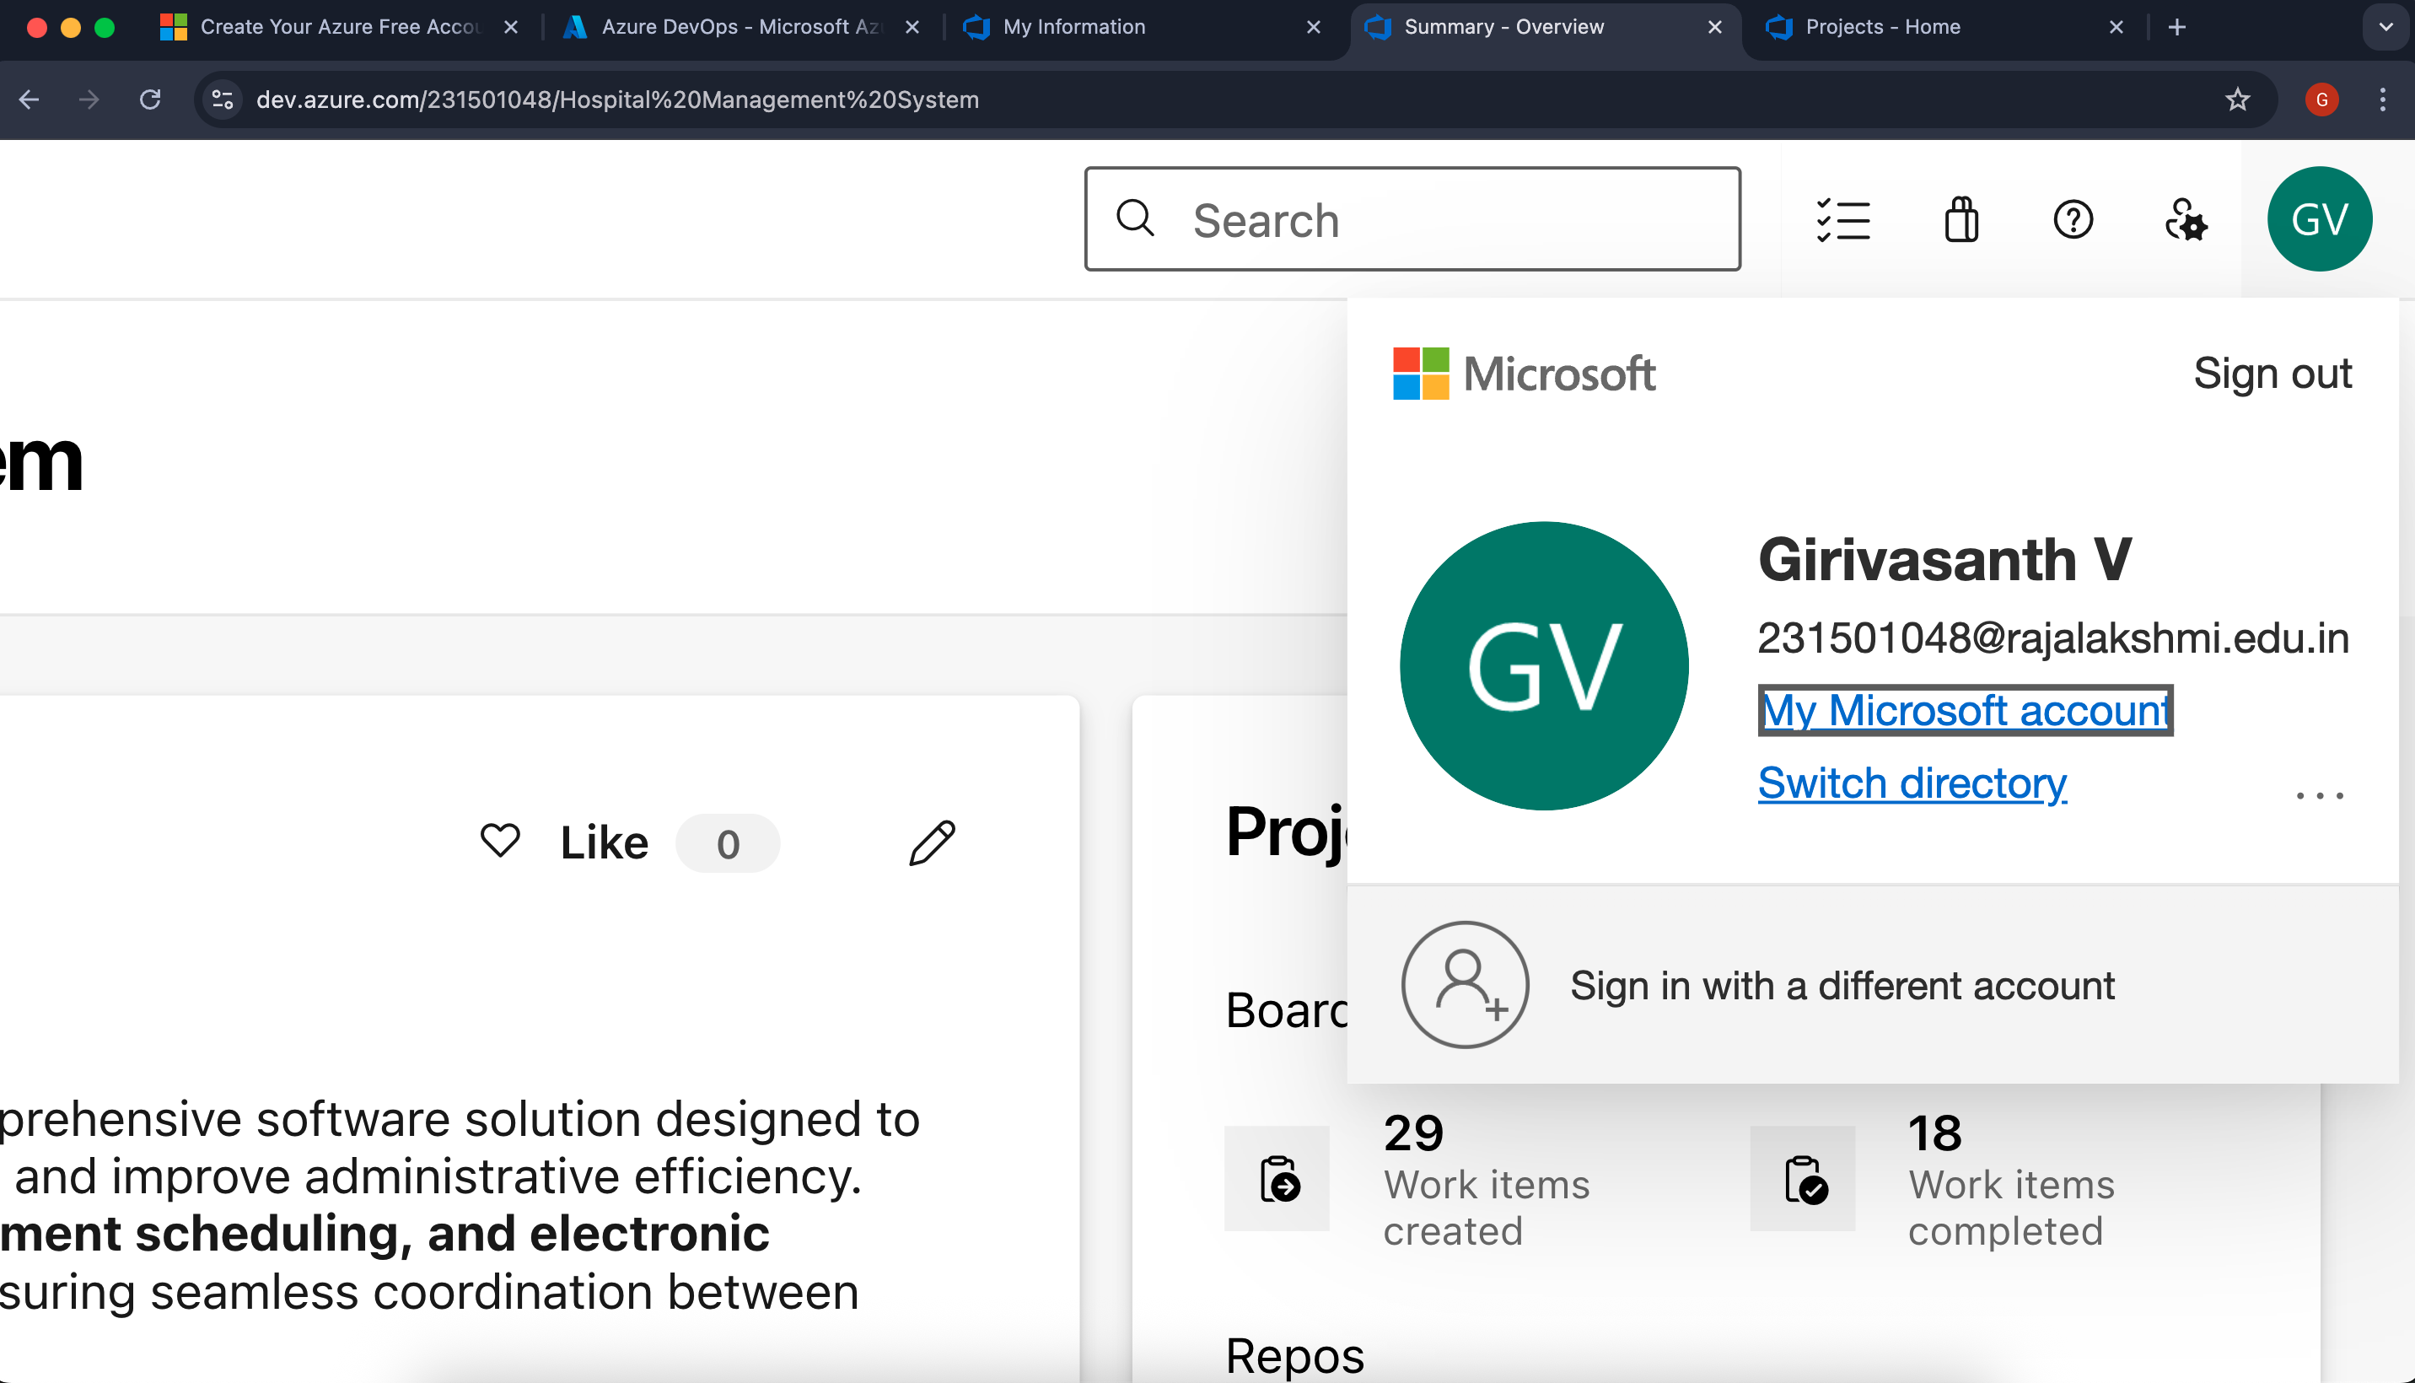

Result:
The Azure DevOps project has been successfully configured with user story management capabilities and agile workflow implementation.

SETTING UP EPICS, FEATURES, AND USER STORIES FOR PROJECT PLANNING

EXP NO: 3
Aim:
Create Epic, Features, User Stories, Task
To create and organize epics, features, user stories, and backlogs in Azure DevOps for streamlined project execution.

Create Epic, Features, User Stories, Task
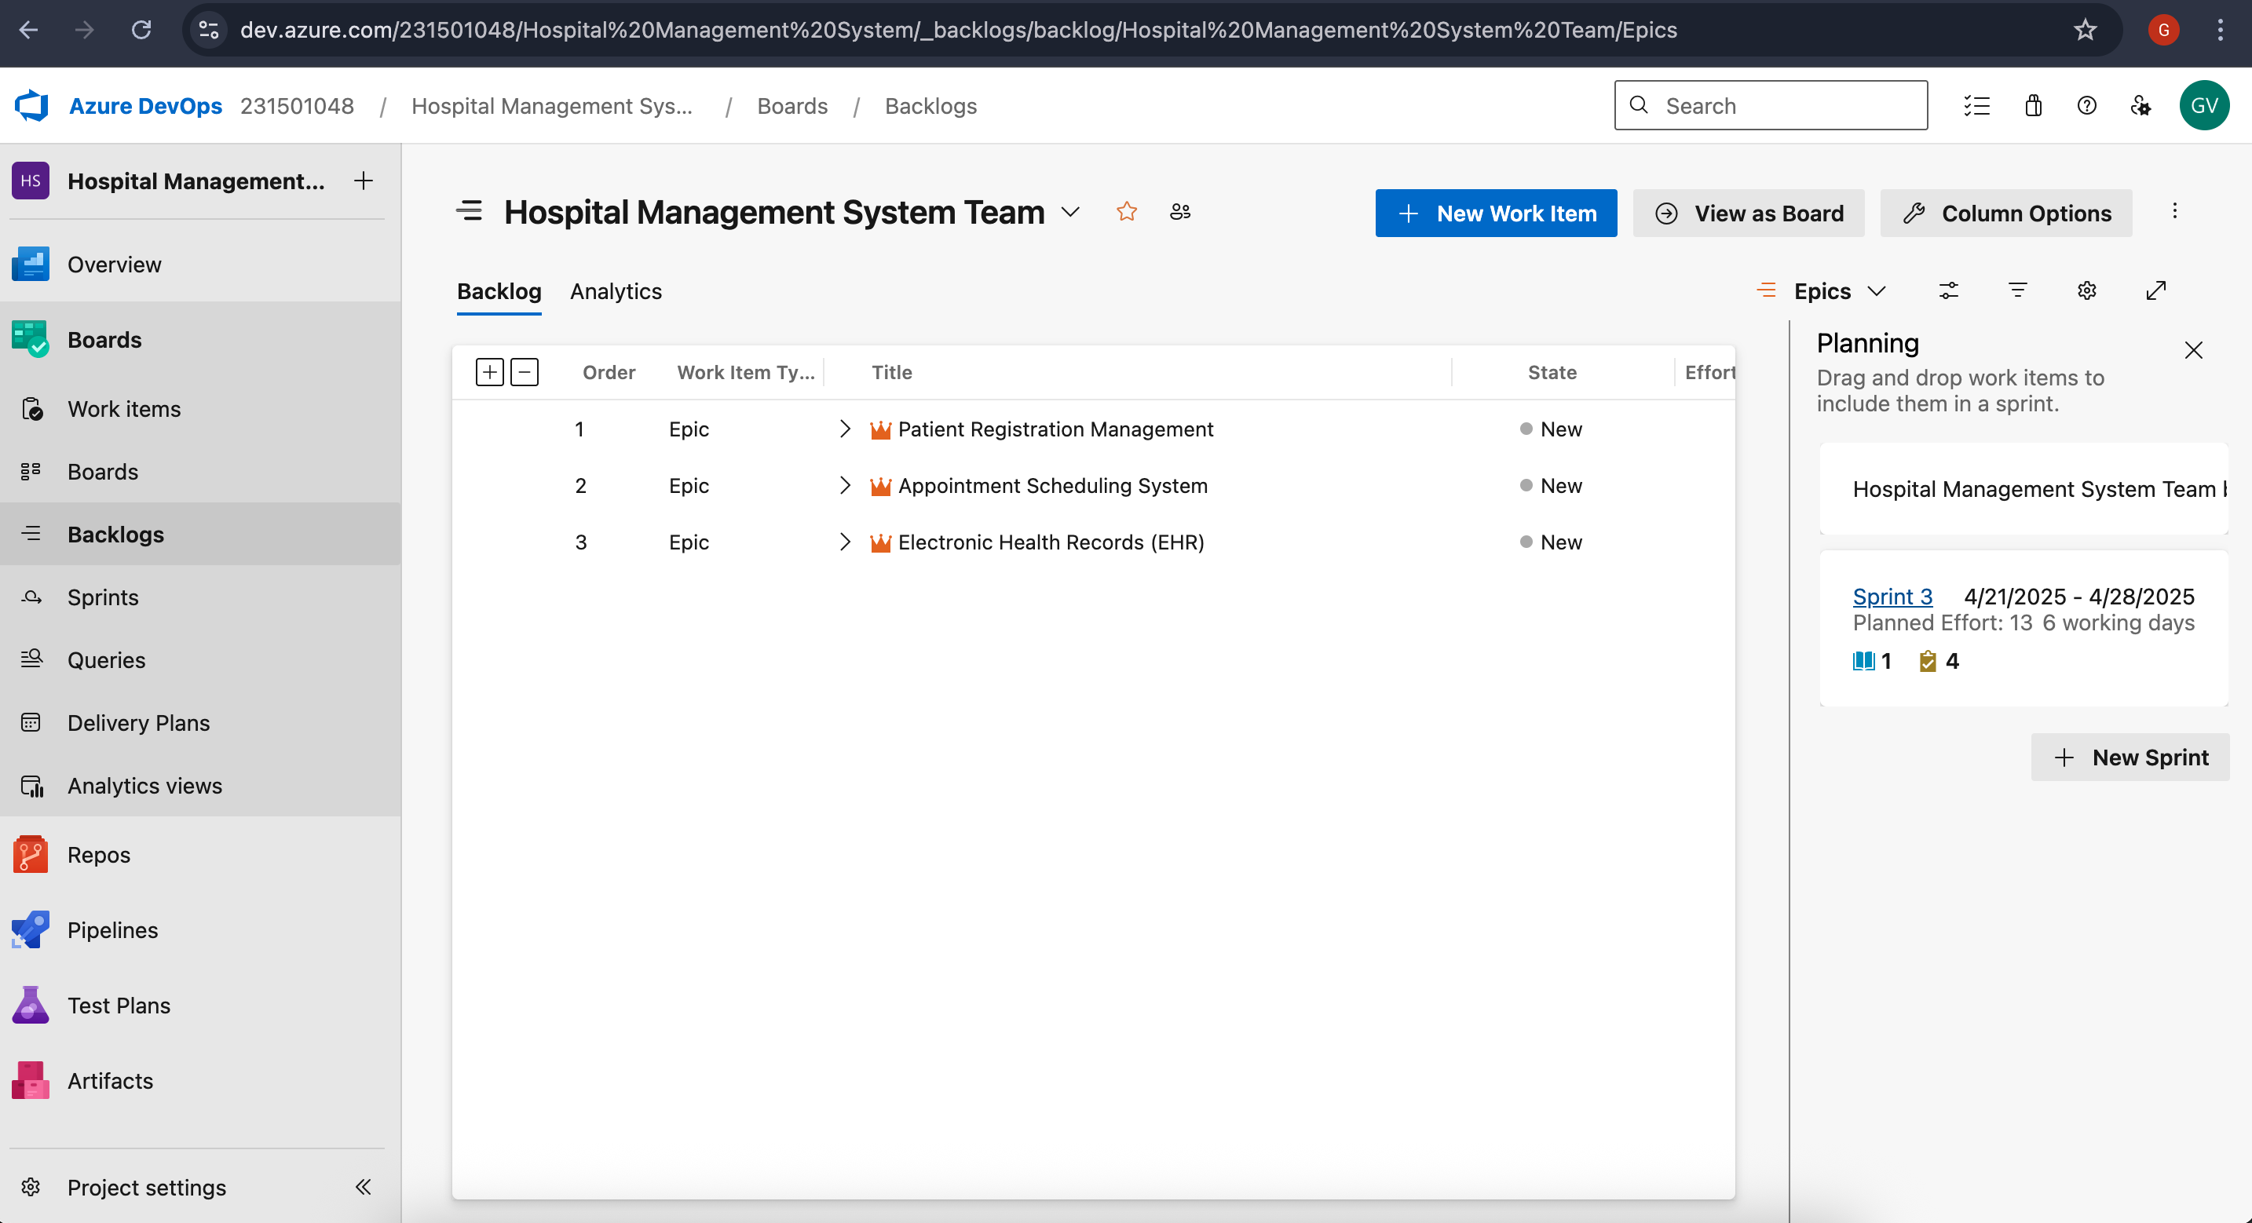

- Create Epic and Fill the Details
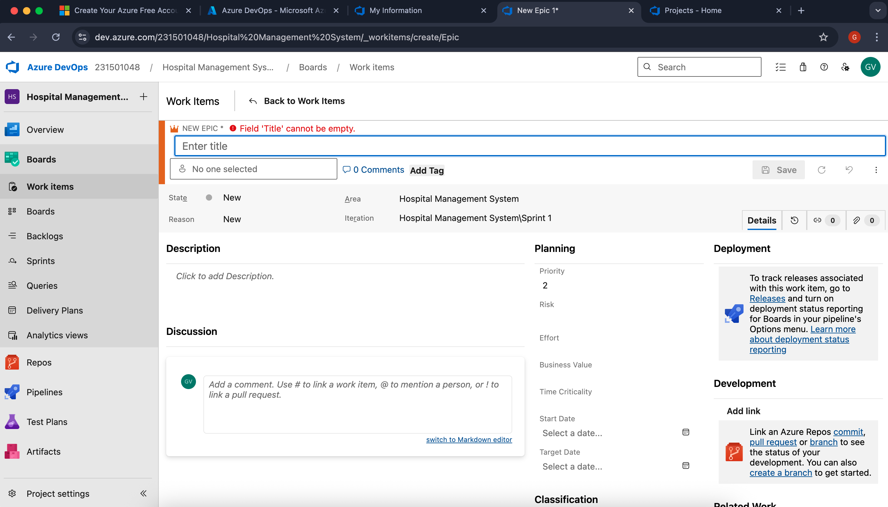

- Create Feature and Fill the Details
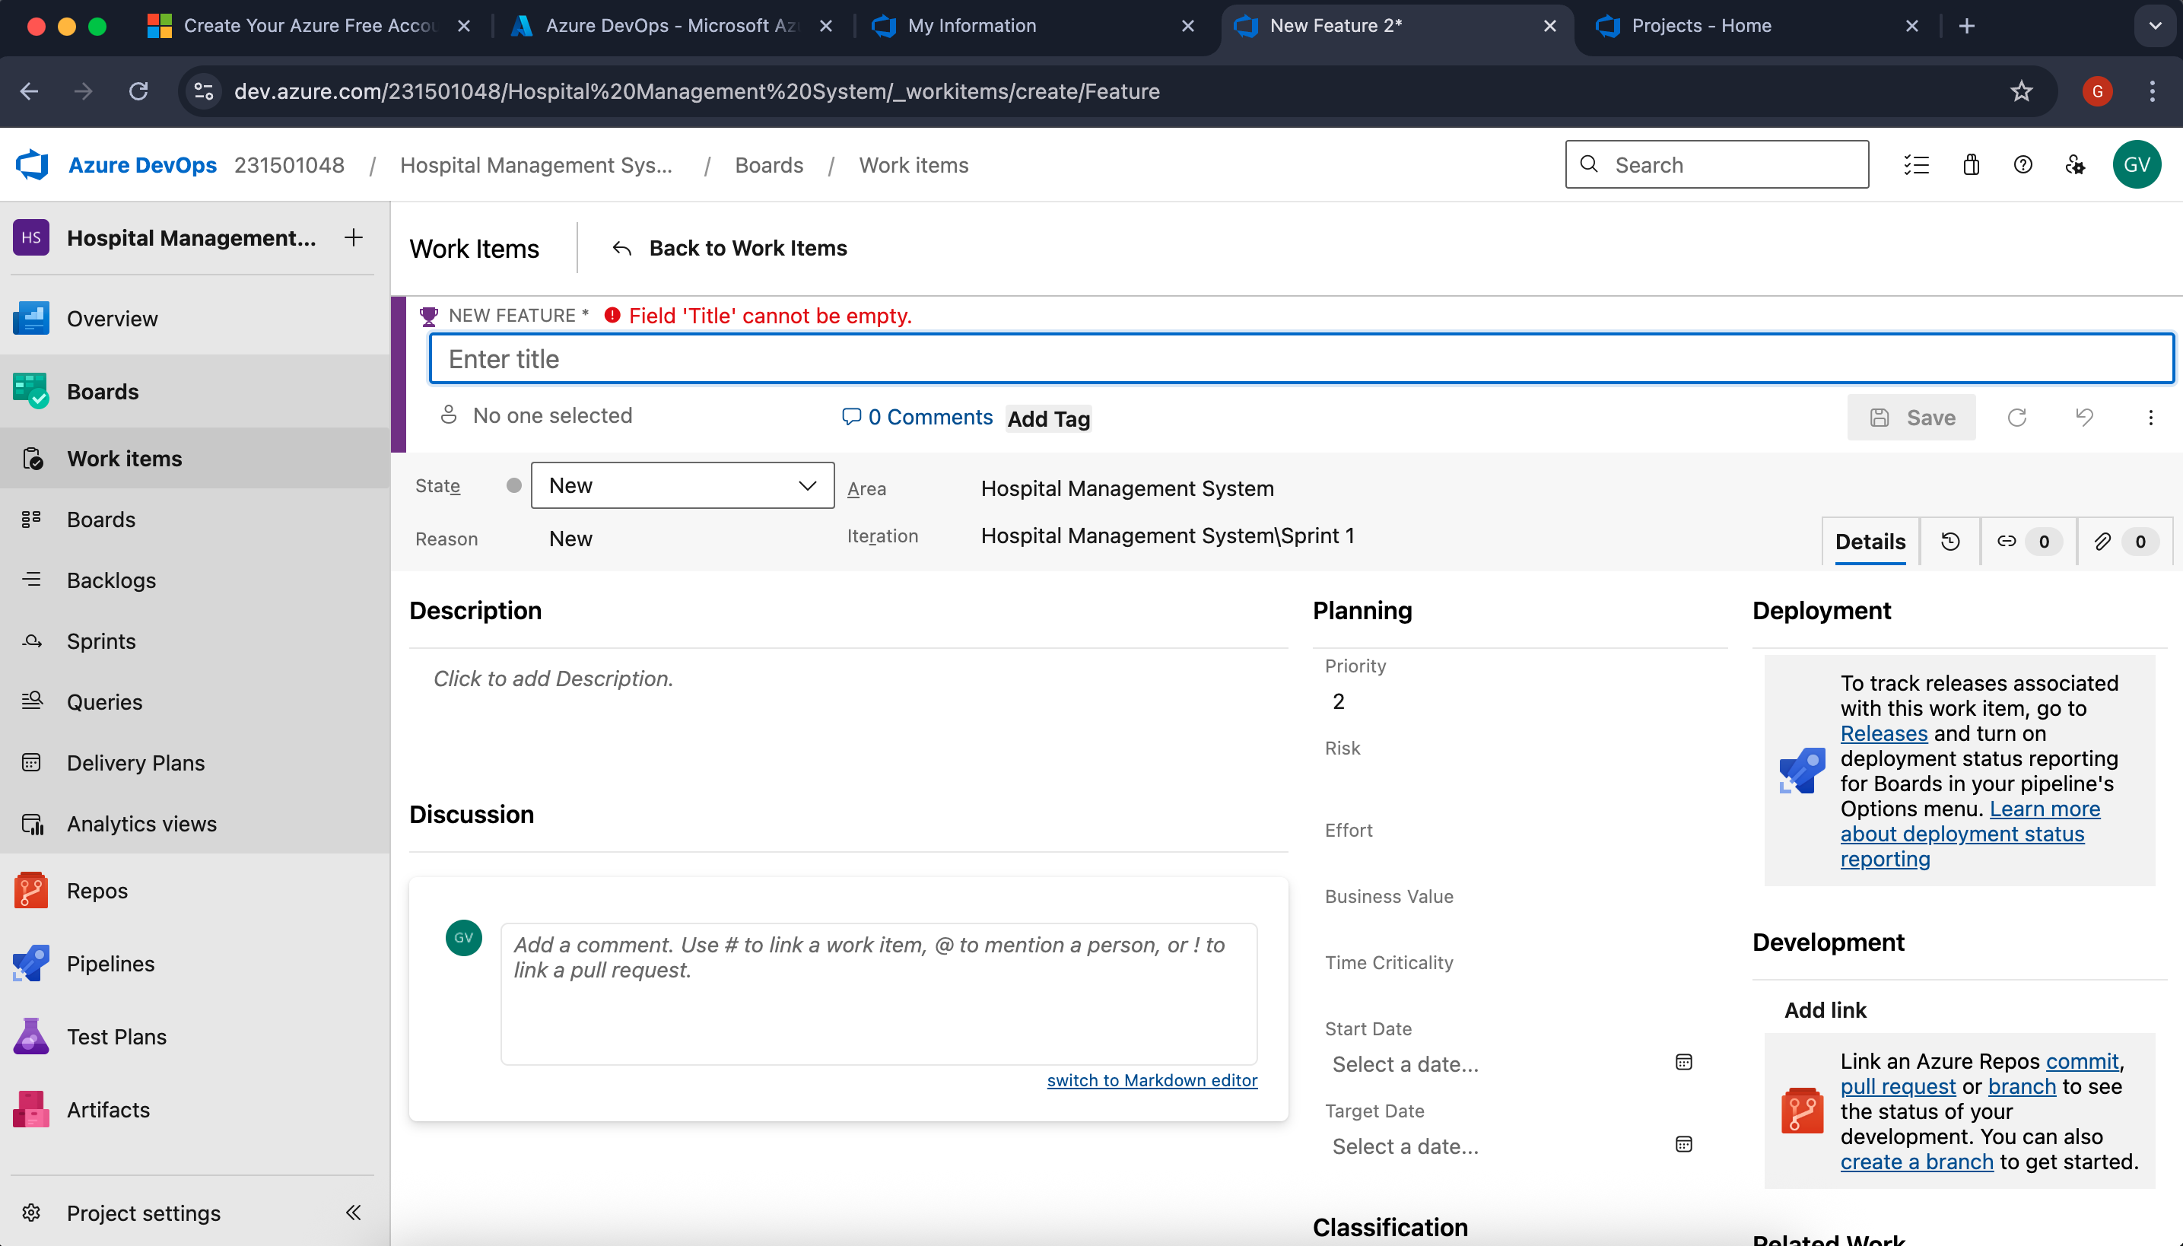

- Create User Story and Fill the Details
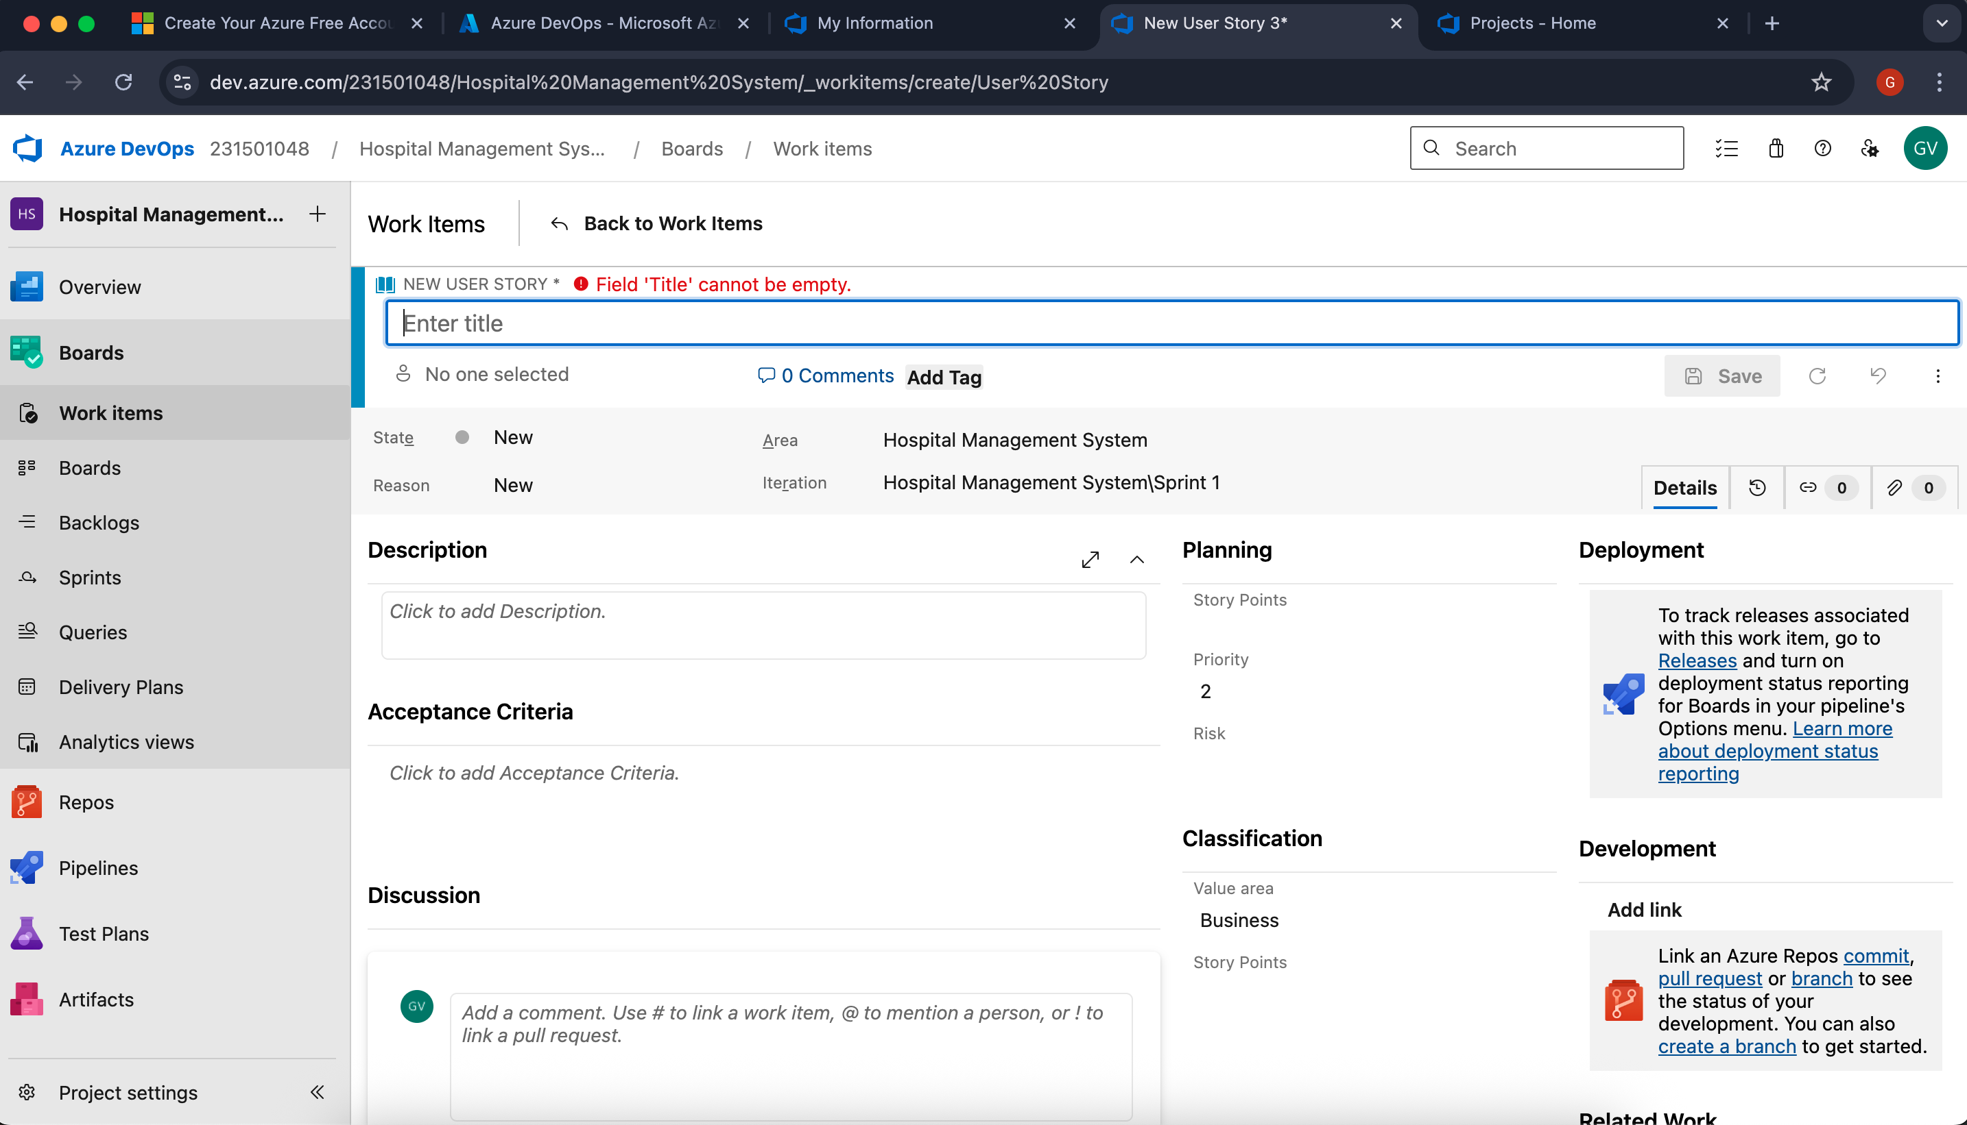

4.Create Task and Fill the Details
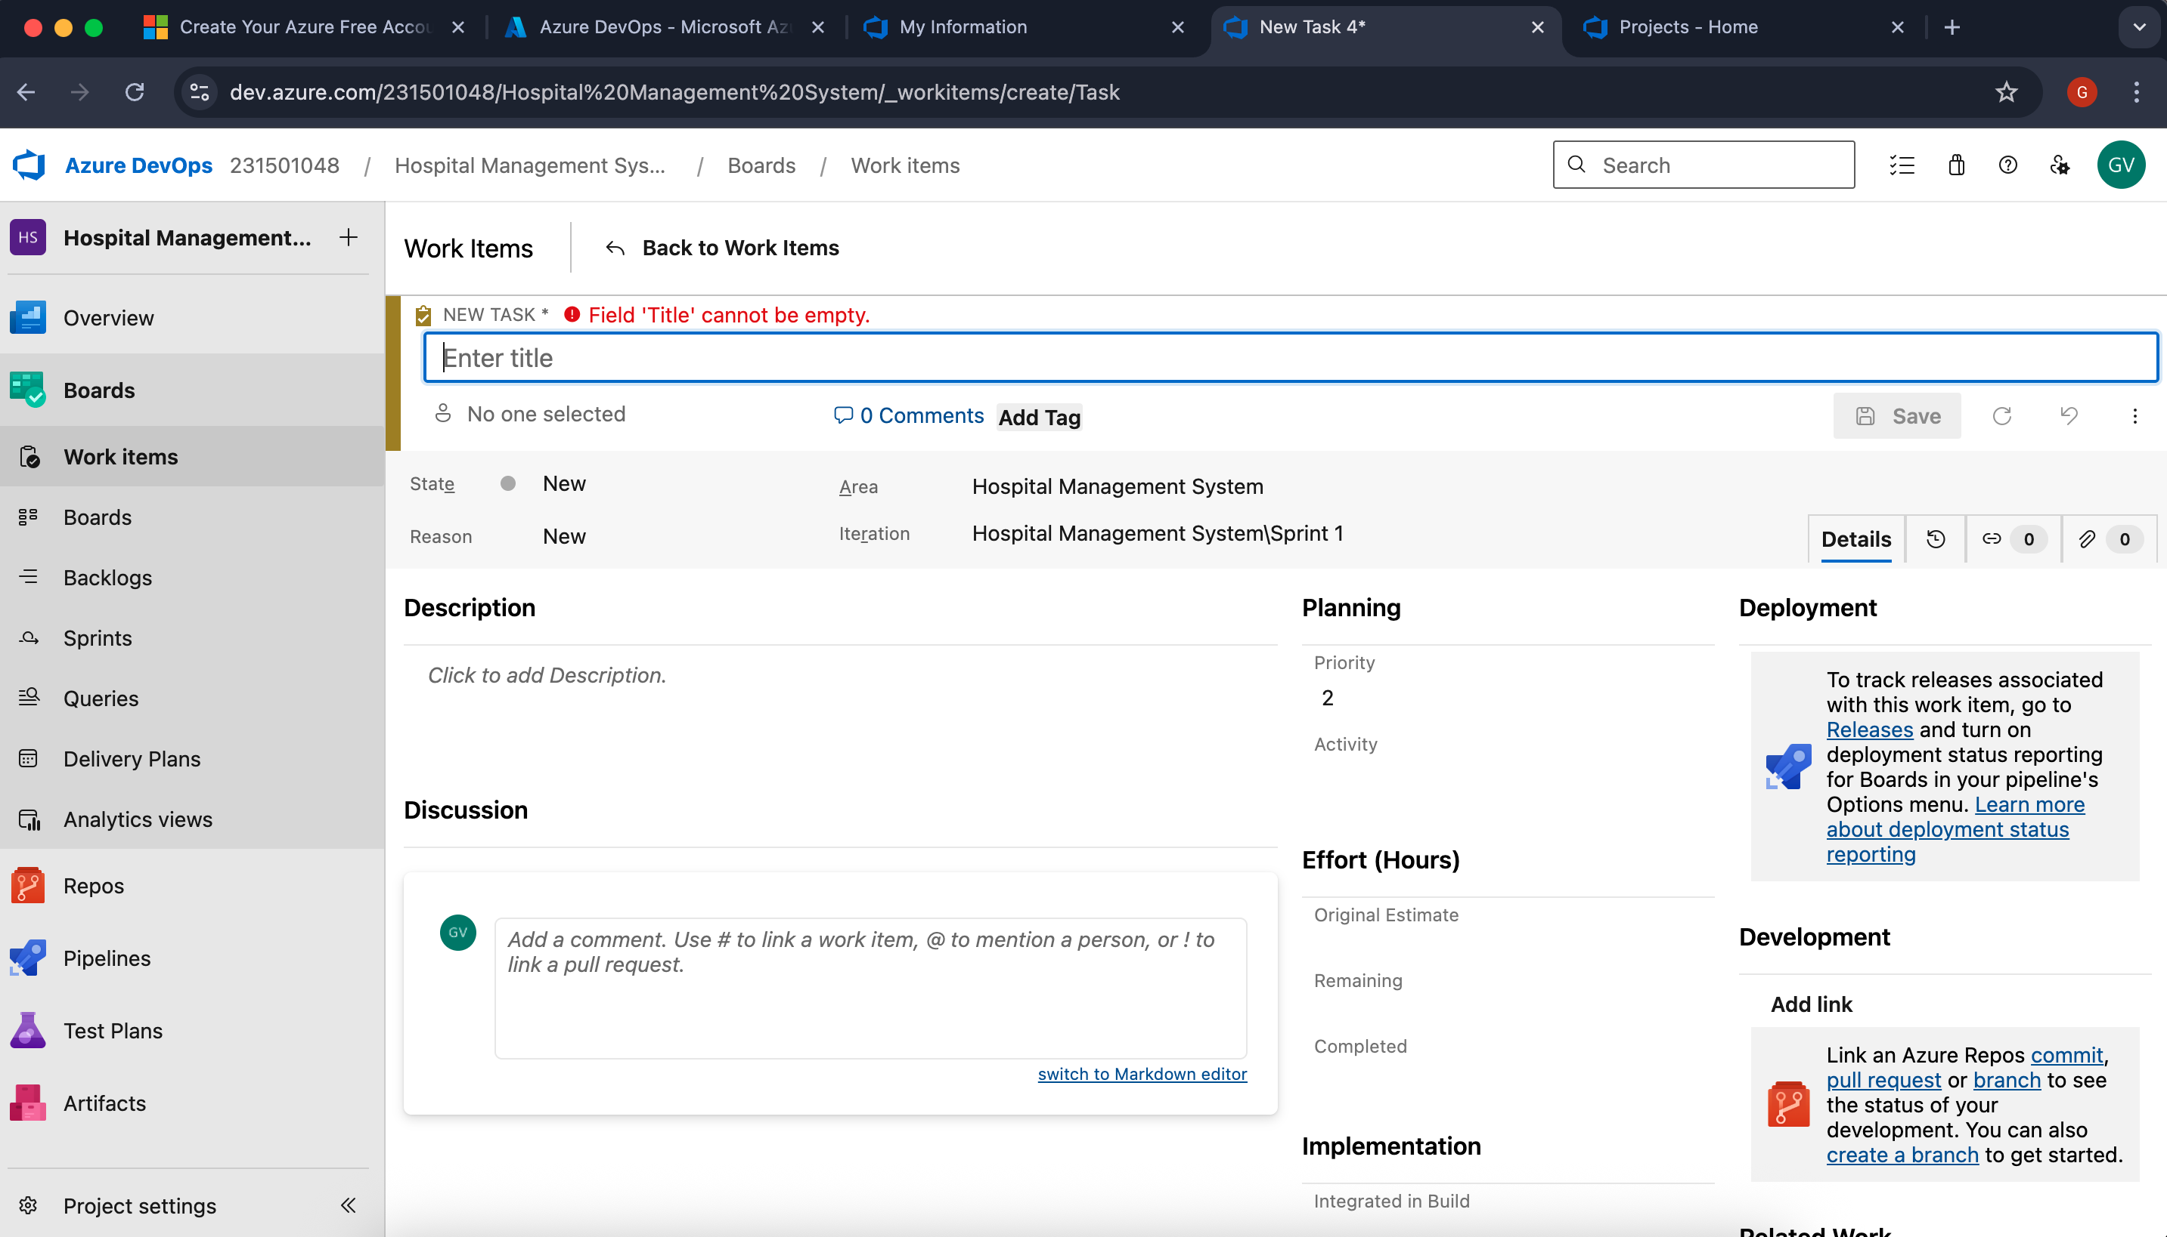

Result:
Thus, the creation of epics, features, user story and task has been created successfully.

SPRINT PLANNING

EXP NO: 4

Aim:
Create Epic, Features, User Stories, Task
To allocate user stories to designated sprints for the Hospital Management System project.

Sprint Planning Sprint 1
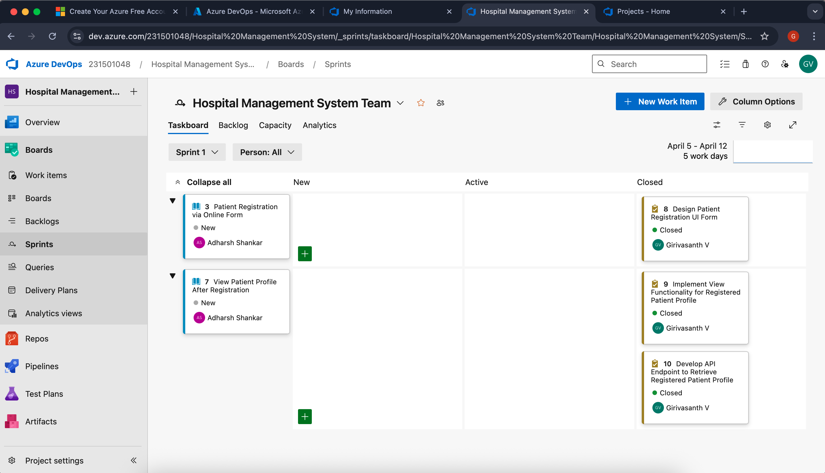

Sprint 2
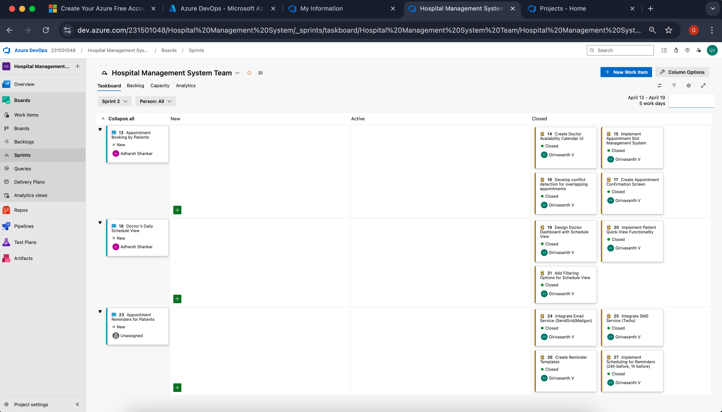

Sprint 3
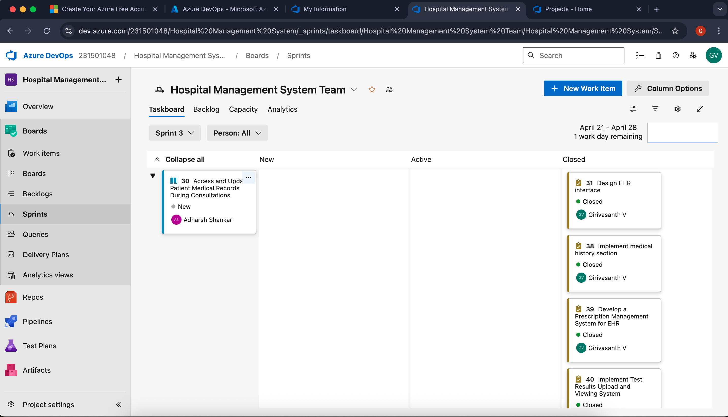

Result:
Agile sprints have been configured for the Hospital Management System initiative.

POKER ESTIMATION

EXP NO: 5

Aim:
Create Epic, Features, User Stories, Task
Create Poker Estimation for the user stories – Hospital Management System Project.

Poker Estimation
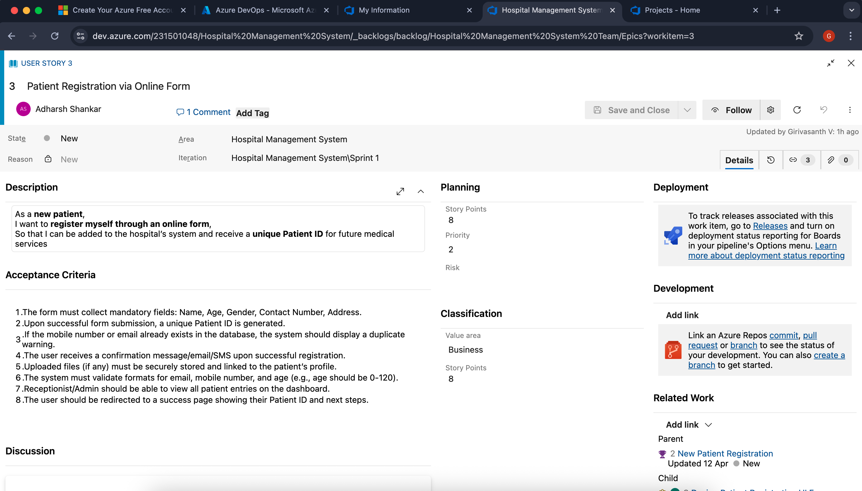

Result:
Project estimations were determined via Planning Poker, assigning story points to each user story.

DESIGNING CLASS AND SEQUENCE DIAGRAMS FOR PROJECT ARCHITECTURE

EXP NO: 6

Aim:
Create Epic, Features, User Stories, Task
To Design a Class Diagram and Sequence Diagram for the given Project.

6A. Class Diagram
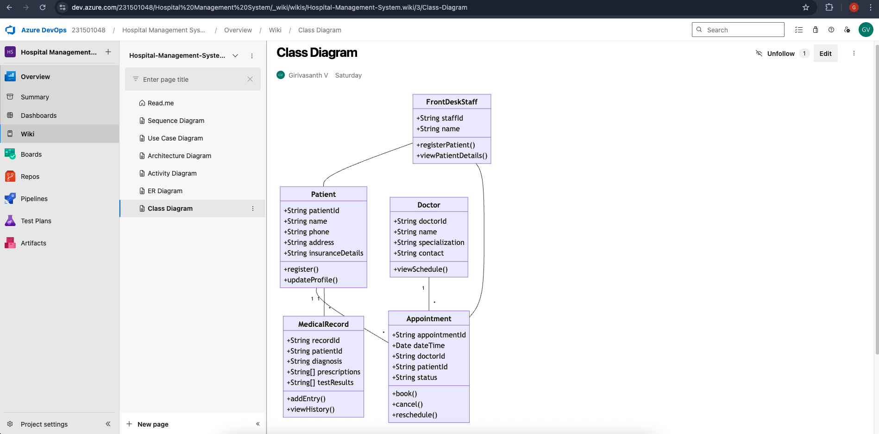

6B. Sequence Diagram
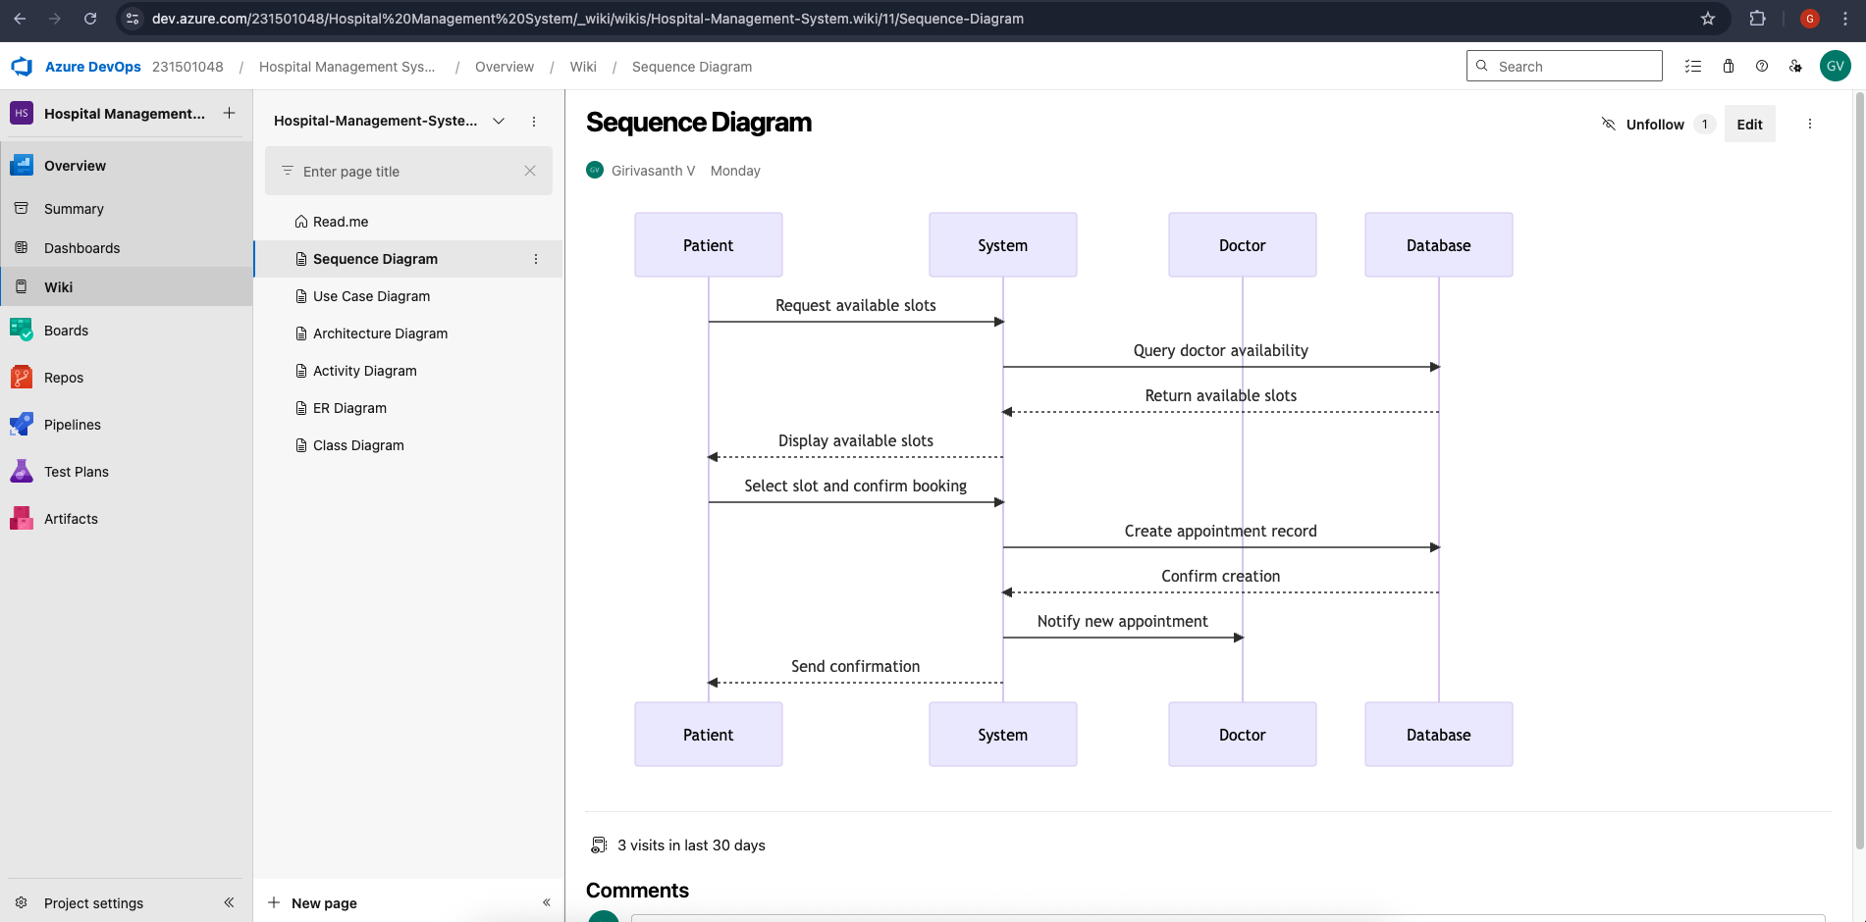

Result:
The Class Diagram and Sequence Diagram have been successfully designed for the Hospital Management System.
DESIGNING ARCHITECTURAL AND ER DIAGRAMS FOR PROJECT STRUCTURE

EXP NO: 7

Aim:
Create Epic, Features, User Stories, Task
To Design an Architectural Diagram and ER Diagram for the given Project.

7A. Architectural Diagram
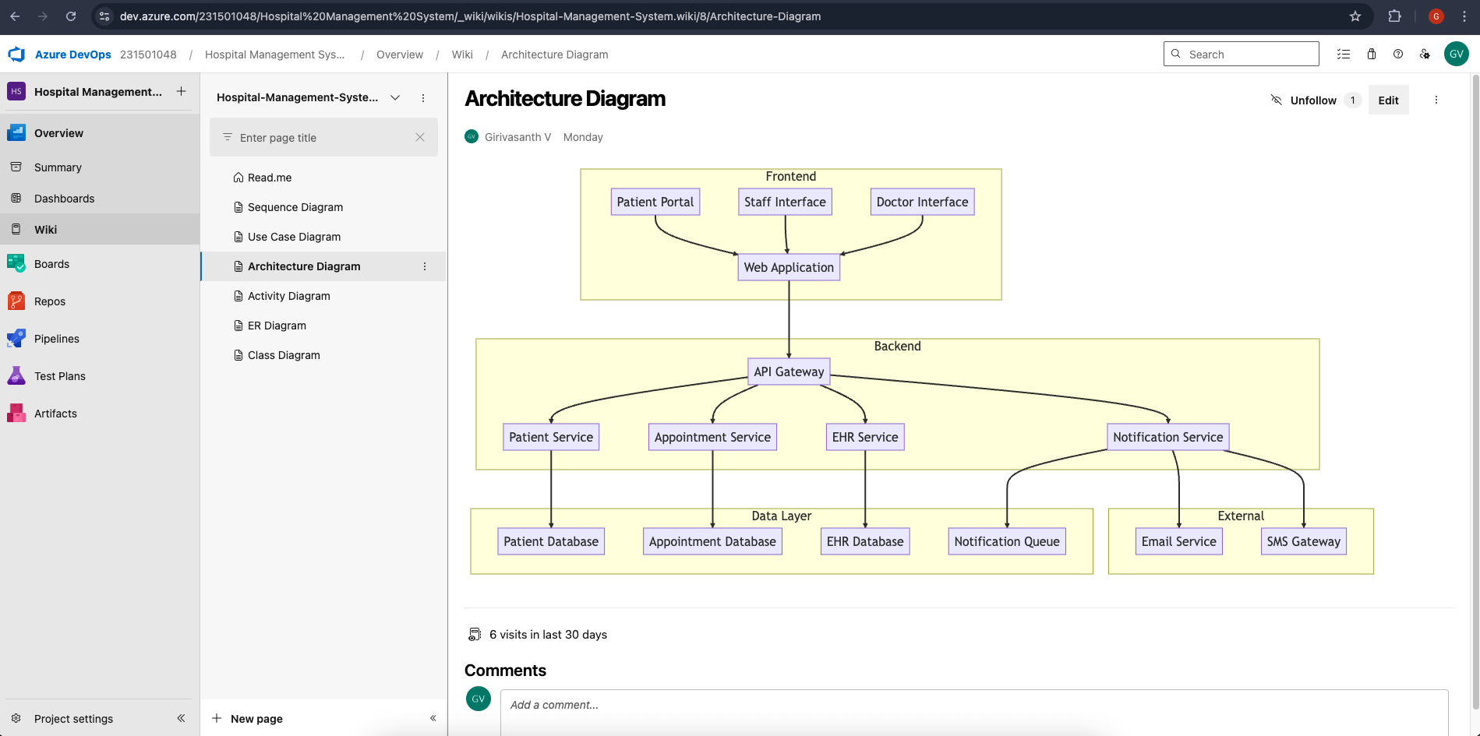

7B.ER Diagram
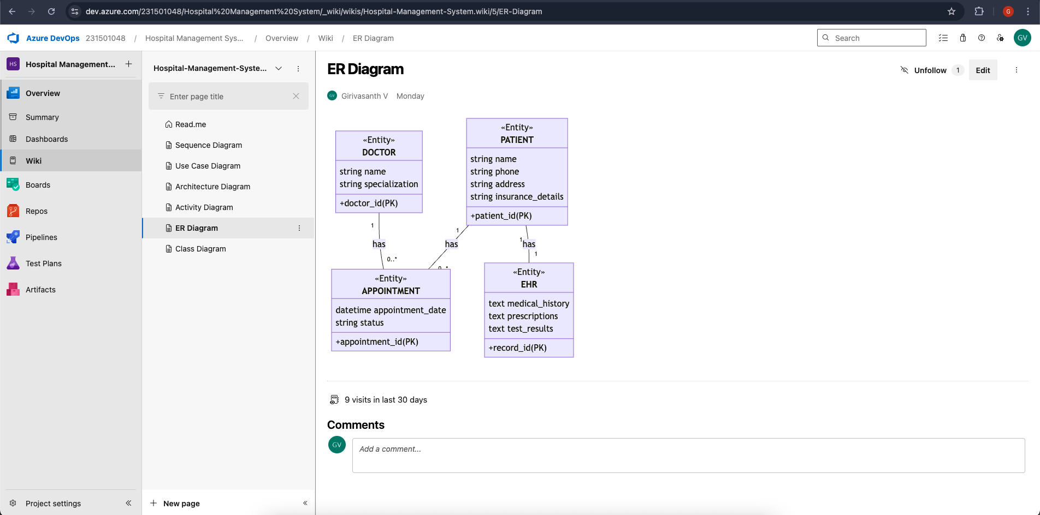

Result:

The Architecture Diagram and ER Diagram have been successfully designed for the Hospital Management System.

TESTING – TEST PLANS AND TEST CASES

EXP NO: 8
Aim:
Create Epic, Features, User Stories, Task
Develop test plans in Azure DevOps featuring two test cases per user story (one successful execution path and one error scenario) for five selected user stories.

Test Planning and Test Case Test Case Design Procedure
1.Understand Core Features
- Patient Registration & Management
- Appointment Scheduling
- Electronic Health Records (EHR)
- Doctor Schedule Management
- Reporting & Analytics
2.Define User Interactions
- Each test case simulates real hospital workflows:
  - Front desk registering new patients
  - Patients booking appointments
  - Doctors updating medical records
  - Patients viewing test results
3.Design Happy Path Test Cases
- Validate normal system operations:
  - Successful patient registration
  - Correct appointment booking
  - Proper EHR updates
  - Accurate schedule displays
4.Design Error Path Test Cases
- Test system error handling:
  - Registration with missing fields
  - Booking unavailable time slots
  - Unauthorized EHR access attempts
  - Offline system operations
5.Break Down Steps and Expected Results
- Each test includes:
  - Clear step-by-step actions
  - Specific expected outcomes
  - Example: Action: Book appointment Expected: Slot marked booked, confirmation sent
6.Use Clear Naming and IDs
- Consistent naming convention:
- TC-REG-01: Successful Registration
- TC-APP-02: Prevent Double-Booking
- TC-EHR-03: Block Unauthorized Access
7.Organize Test Suites
- Group by functionality:
- TS-REG: Registration tests
- TS-APP: Appointment tests
- TS-EHR: Medical records tests
- TS-SEC: Security tests
8.Prioritize and Review
- Mark critical tests (P0):
Data security
Appointment conflicts
EHR accuracy
- Review for:
Requirement coverage
Edge cases
Compliance needs (HIPAA/GDPR)

- New test plan
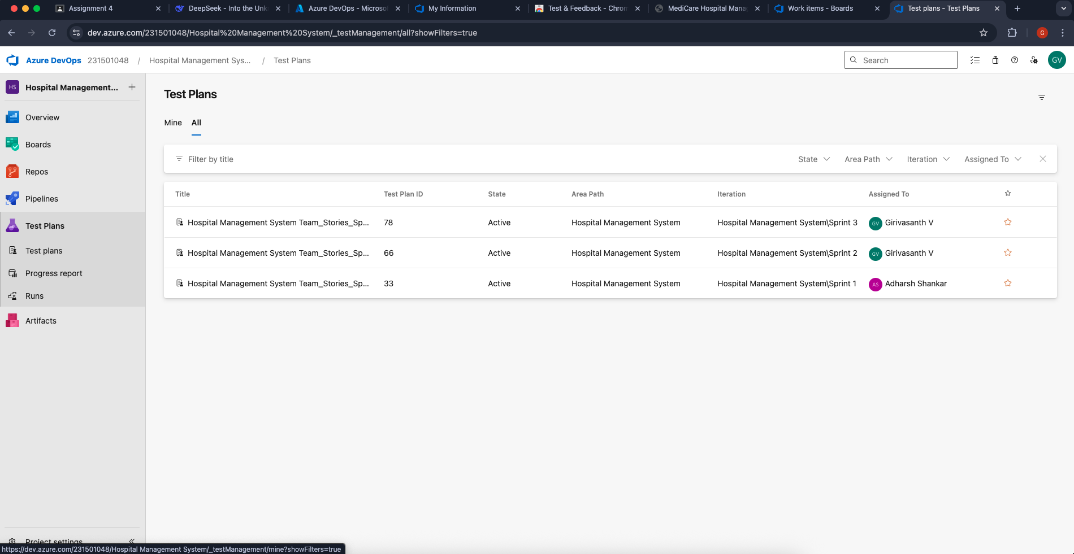

- Test suite
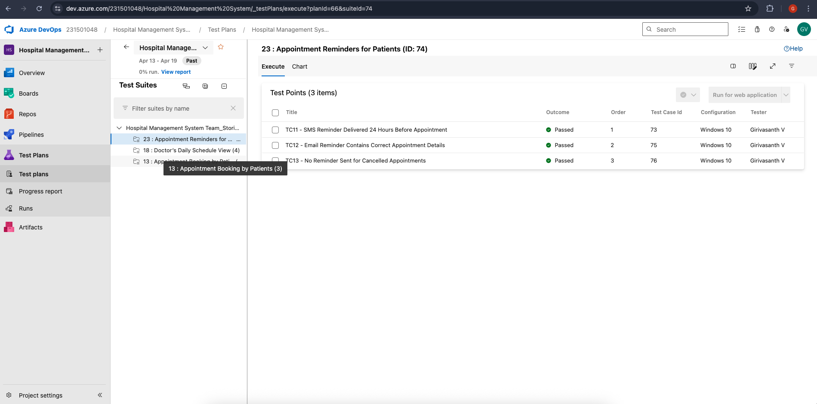

- Test case
Provide two test cases for at least five user stories, demonstrating both happy path (success scenarios) and error path (failure scenarios) in Azure DevOps.
USER STORIES
- As a hospital receptionist or admin I want to view the complete patient profile after registration,
So that I can verify the details, make updates if required, and manage the patient’s visit efficiently.
- As a new patient,I want to register myself through an online form,
So that I can be added to the hospital’s system and receive a unique Patient ID for future medical services

As a doctor, I want to view my daily schedule with patient details so I can prepare for consultations.
- As a patient, I want to receive appointment reminders via SMS or email so I don't miss my appointment.
Test Suites
Test Suite: TS01 - Patient Registration (ID: 91)
- TC01 – Successful Patient Registration
- Action:
  - Go to the Patient Registration page.
  - Enter valid patient details (name, phone, address, insurance).
  - Click "Register".
  - Expected Results:
    - Registration form is displayed.
    - Fields accept values without error.
    - Unique patient ID is generated and patient is redirected to confirmation page.
    - Type: Happy Path
- TC02 – Registration with Missing Mandatory Fields
  - Action:
    - Go to the Patient Registration page.
    - Leave one mandatory field blank.
    - Click "Register".
  - Expected Results:
    - Error message appears highlighting the missing field.
    - Registration is not completed.
    - Type: Error Path
- TC03 – Duplicate Patient Detection
  - Action:
    - Register a new patient.
    - Attempt to register the same patient again with identical details.
  - Expected Results:
    - System detects potential duplicate and shows warning message.
    - Option to proceed or view existing patient record.
    - Type: Error Path
Test Suite: TS02 - Appointment Scheduling (ID: 92)
- TC04 – Successful Appointment Booking
  - Action:
    - Log in as patient.
    - Select available doctor and time slot.
    - Confirm booking.
  - Expected Results:
    - Appointment is booked successfully.
    - Confirmation appears with appointment details.
    - Type: Happy Path
- TC05 – Book Already Reserved Time Slot
  - Action:
    - Attempt to book an already booked time slot.
  - Expected Results:
    - Error message "This time slot is no longer available" appears.
    - System suggests nearest available slots.
    - Type: Error Path
- TC06 – Appointment Reminder Notification
  - Action:
    - Book an appointment for tomorrow.
    - Wait for reminder trigger time.
  - Expected Results:
    - SMS/email reminder is sent 24 hours before appointment.
    - Notification contains correct appointment details.
    - Type: Happy Path
Test Suite: TS03 - EHR Access (ID: 93)
- TC07 – Doctor Access to Patient Records
  - Action:
    - Log in as doctor.
    - Search for patient and open EHR.
  - Expected Results:
    - Complete patient medical history is displayed.
    - Doctor can add new notes and prescriptions.
    - Type: Happy Path
- TC08 – Unauthorized EHR Access Attempt
  - Action:
    - Log in as non-treating doctor.
    - Attempt to access patient EHR.
  - Expected Results:
    - Access is denied with "Unauthorized" message.
    - Attempt is logged in audit trail.
    - Type: Error Path
- TC09 – Patient Portal EHR View
  - Action:
    - Log in as patient.
    - Navigate to "My Health Records".
  - Expected Results:
    - Patient can view their complete medical history.
    - No edit options are available.
    - Type: Happy Path
Test Suite: TS04 - Doctor Schedule Management (ID: 94)
- TC10 – View Daily Schedule
  - Action:
    - Log in as doctor.
    - Navigate to "My Schedule".
  - Expected Results:
    - All appointments for the day are displayed chronologically.
    - Patient details are visible for each appointment.
    - Type: Happy Path
- TC11 – Schedule Conflict Detection
  - Action:
    - Attempt to schedule overlapping appointments.
  - Expected Results:
    - System prevents scheduling conflicts.
    - Error message "This would create a schedule conflict" appears.
    - Type: Error Path
Test Suite: TS05 - Reporting (ID: 95)
- TC12 – Generate Patient Report
  - Action:
    - Log in as admin.
    - Select report parameters (date range, department).
    - Click "Generate Report".
  - Expected Results:
    - Report is generated with correct data.
    - Export options (PDF, CSV) are available.
    - Type: Happy Path
- TC13 – Report Generation with Invalid Parameters
  - Action:
    - Select future date range for report.
    - Click "Generate Report".
  - Expected Results:
    - Error message "Invalid date range selected" appears.
    - Report is not generated.
    - Type: Error Path

Test Cases
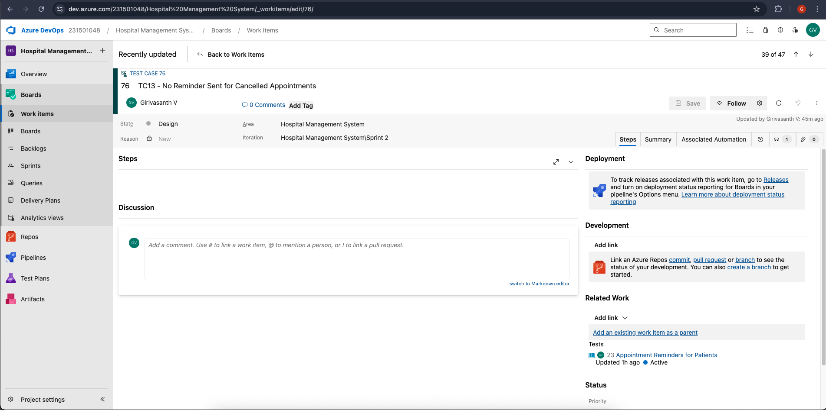

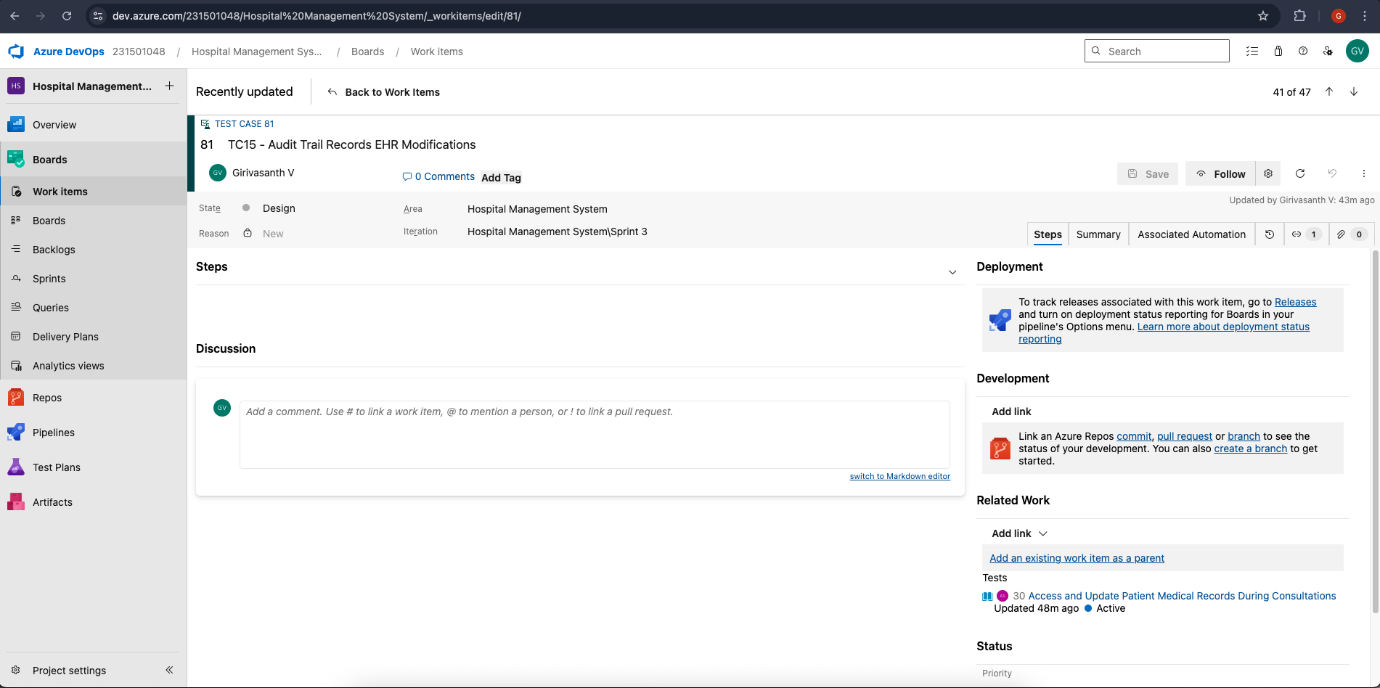

- Installation of test
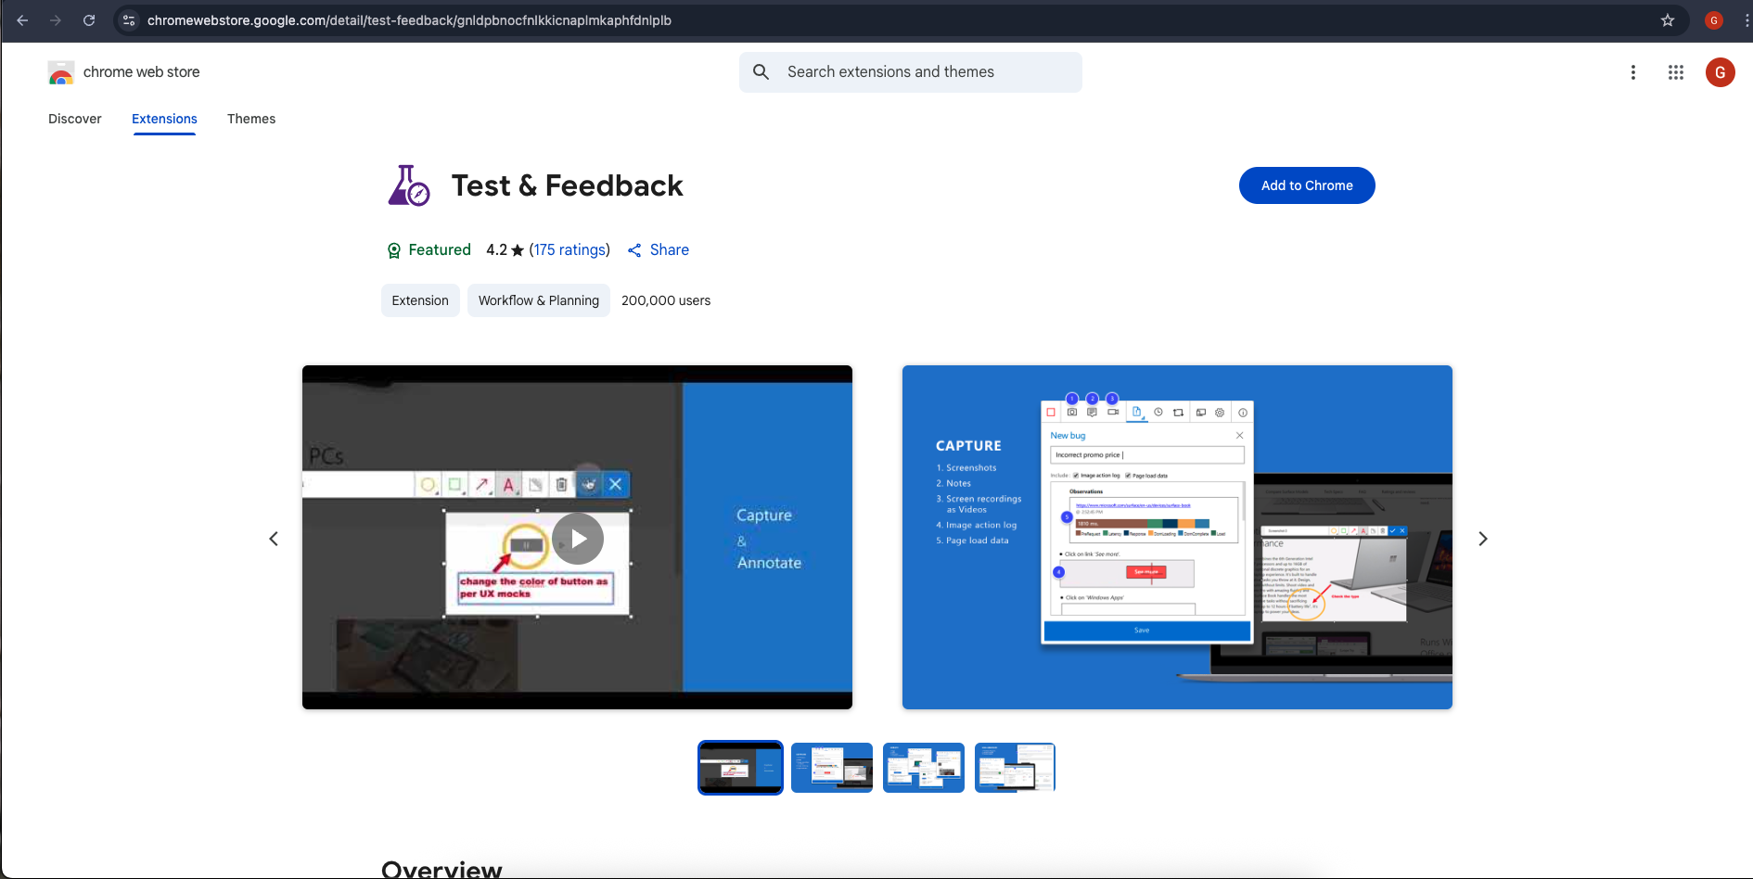

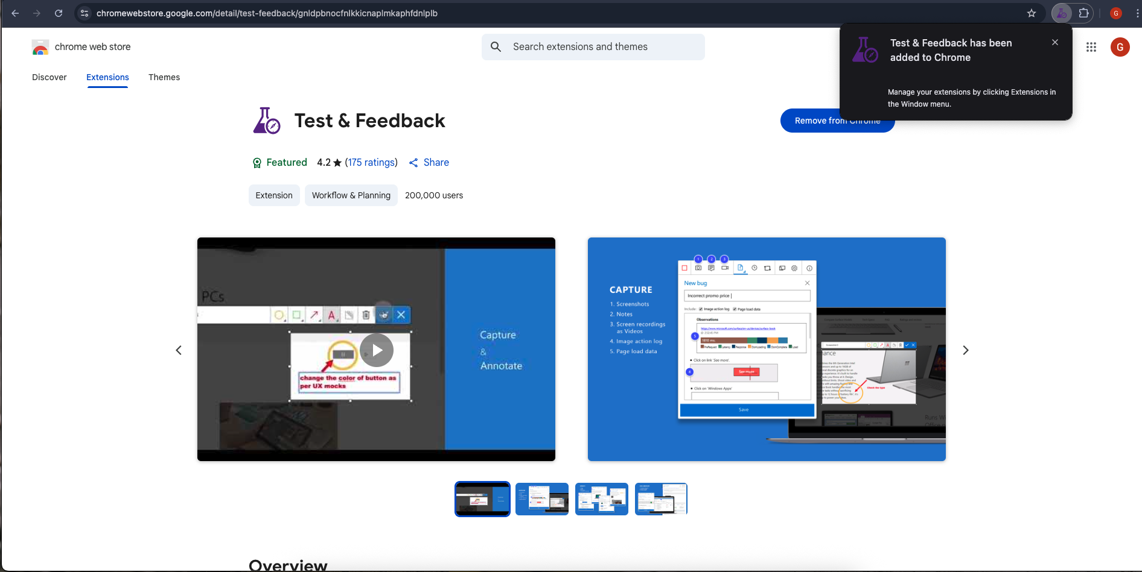

Test and feedback Showing it as an extension
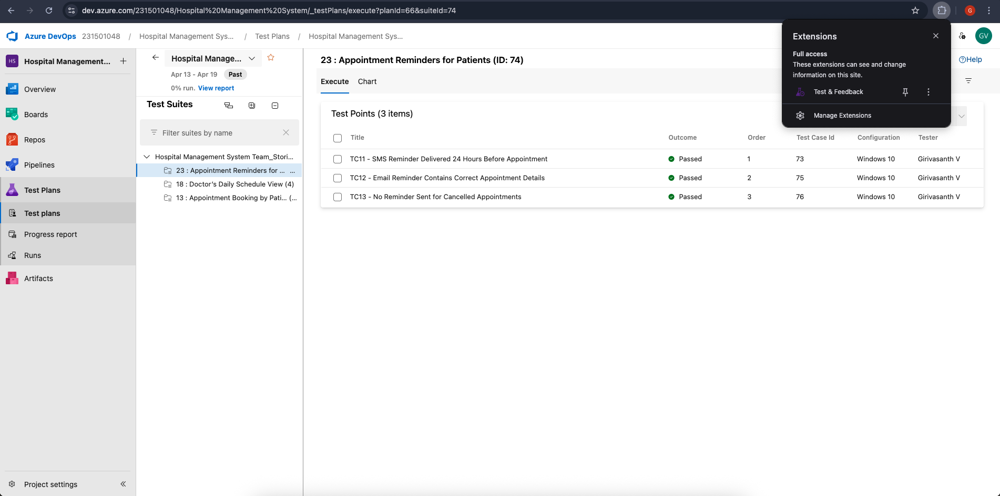

- Running the test cases
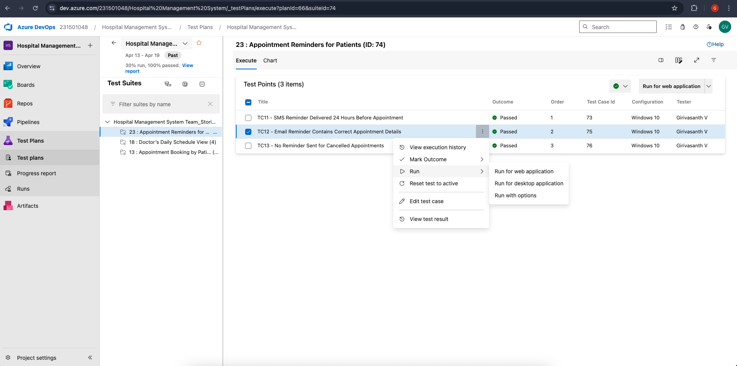

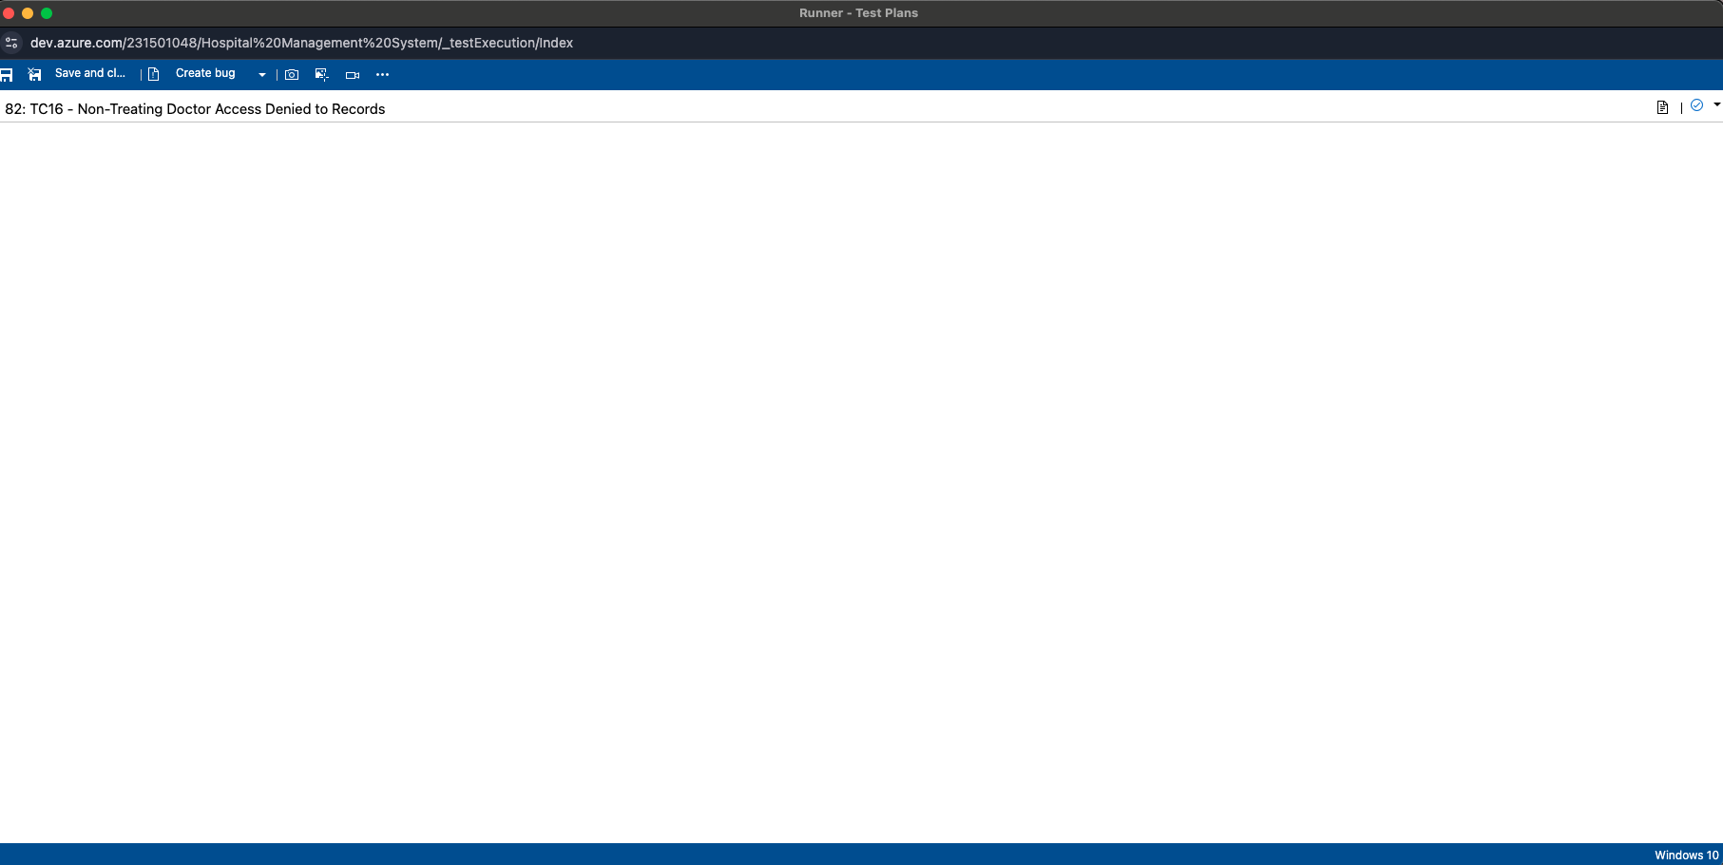
- Recording the test case
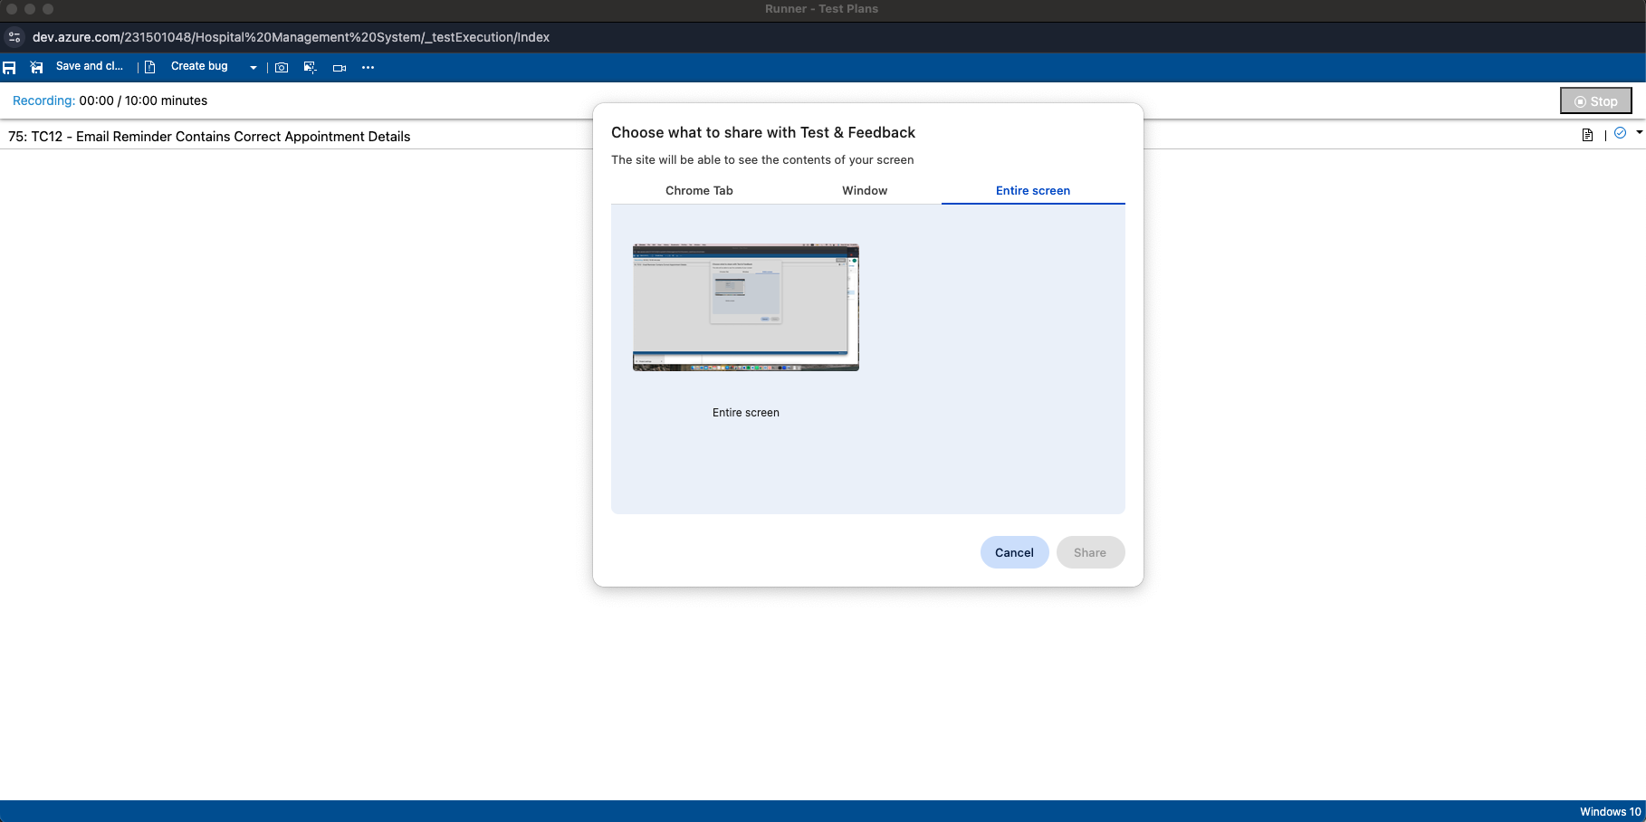

- Creating the bug
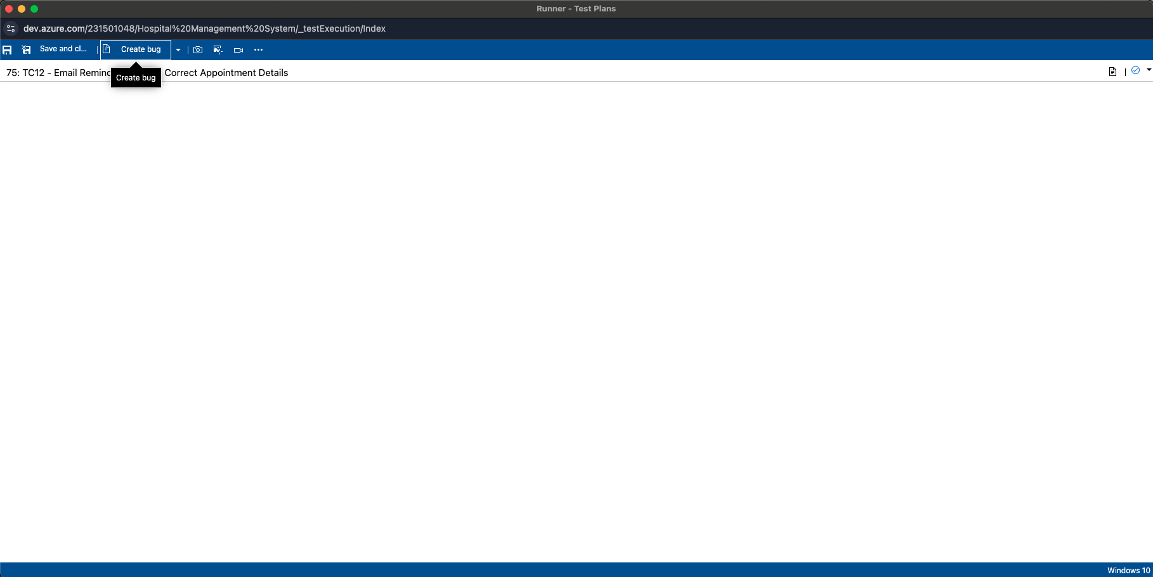

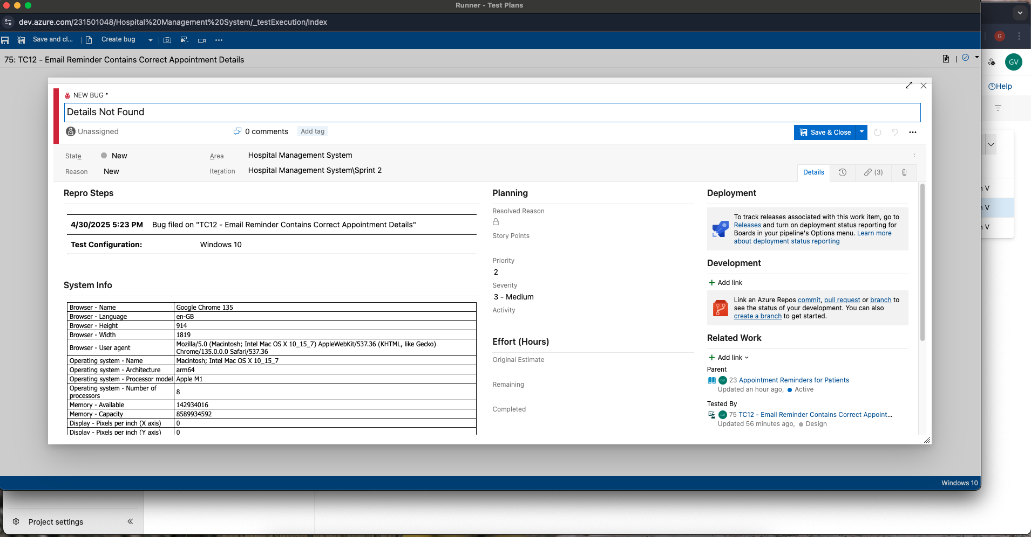
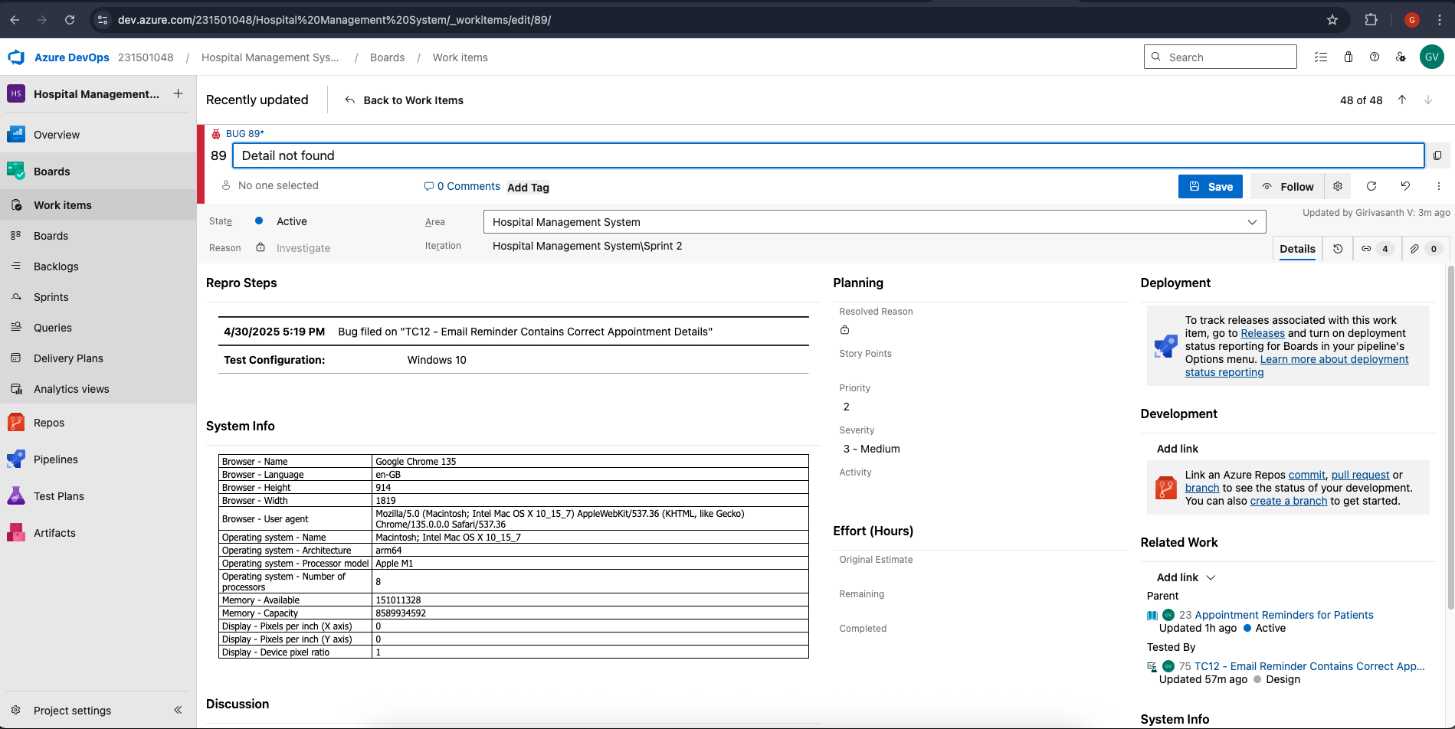

- Test case results
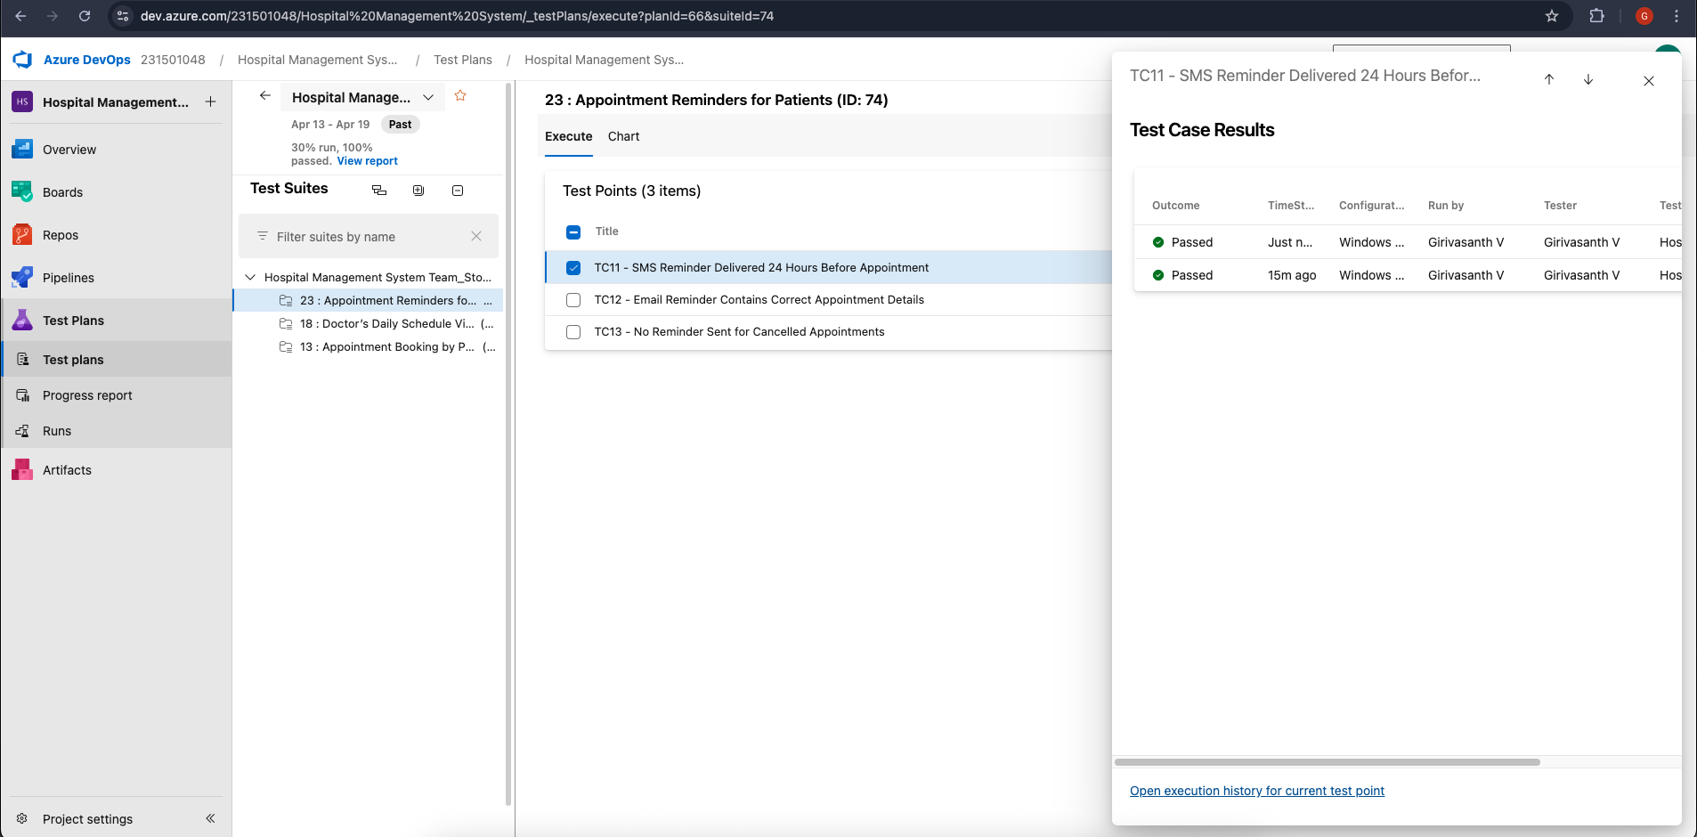

- Test report summary
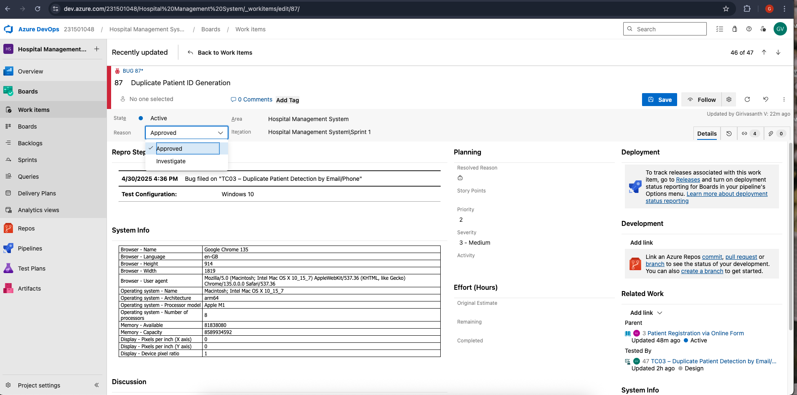

  - Assigning bug to the developer and changing state

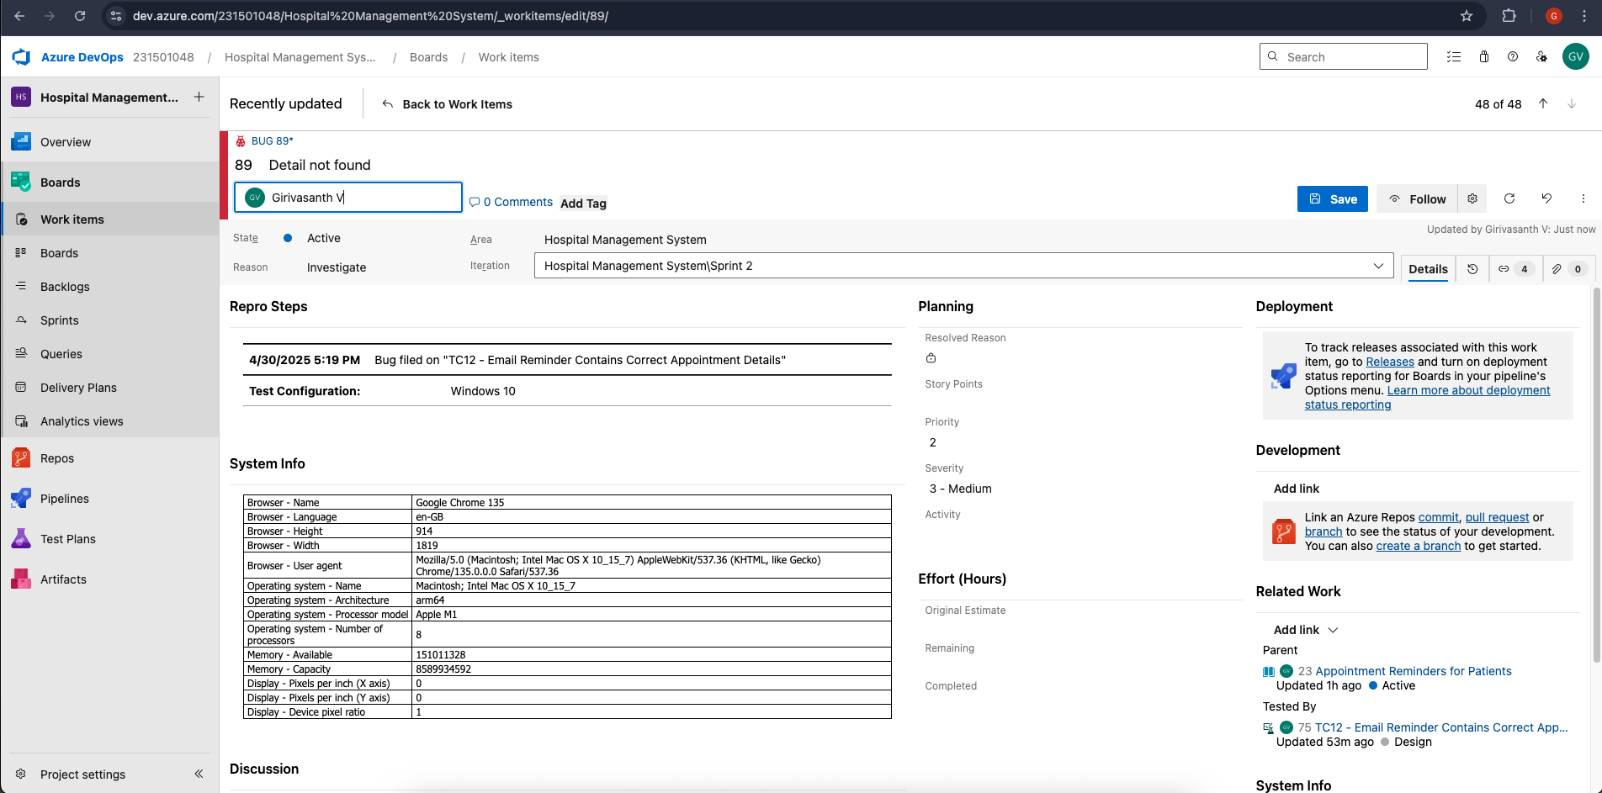

- Progress report
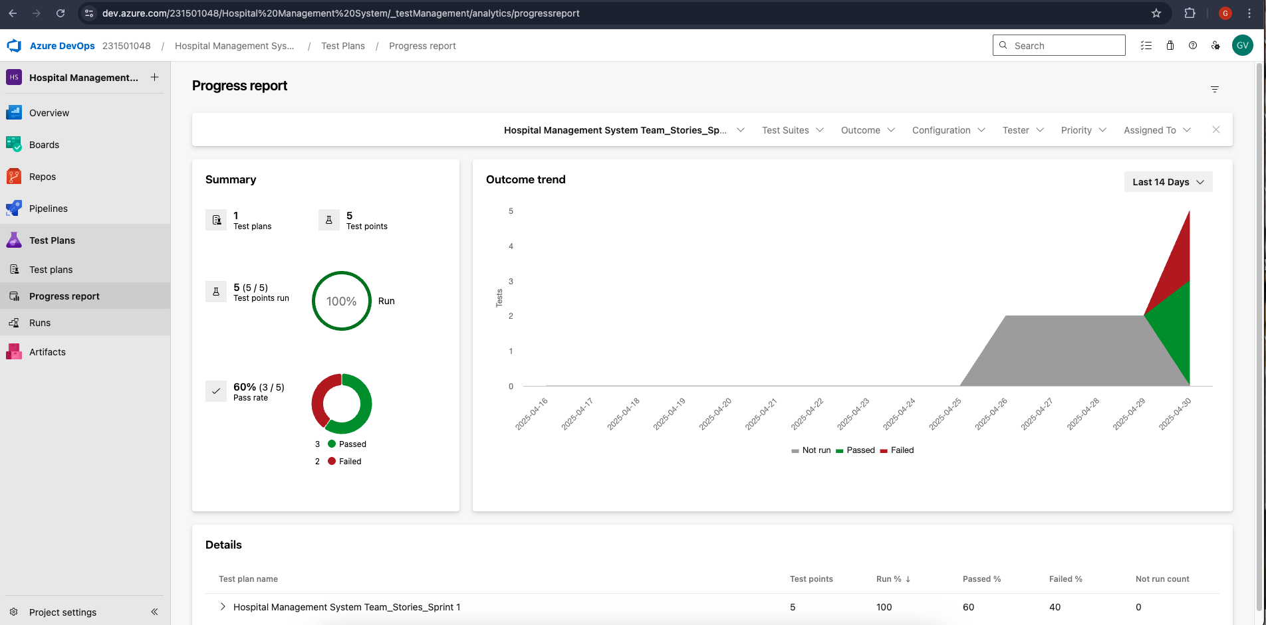

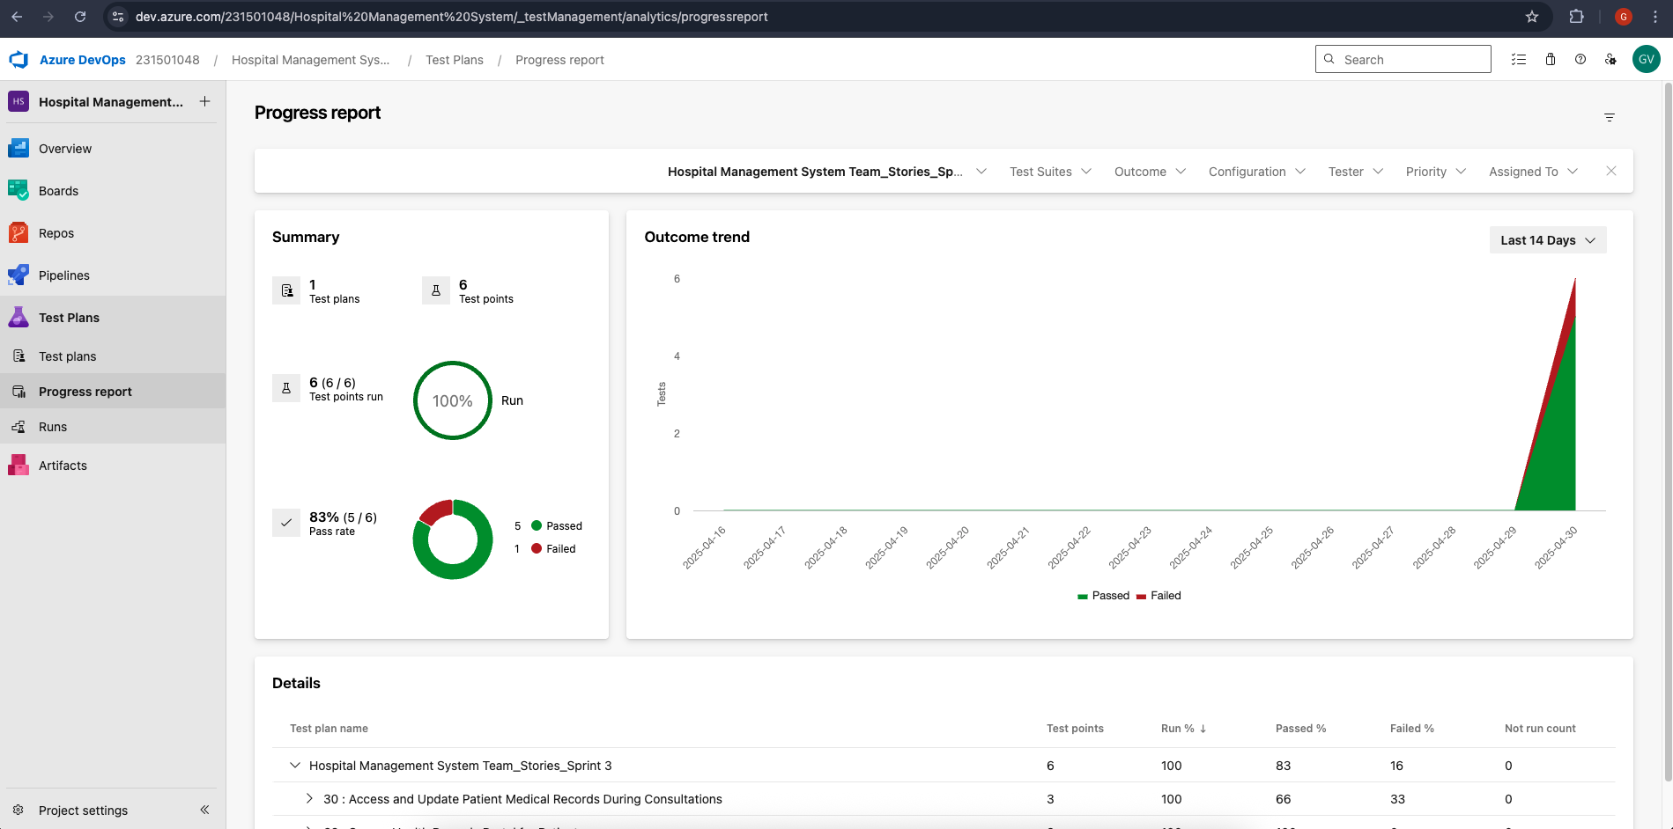

- Changing the test template

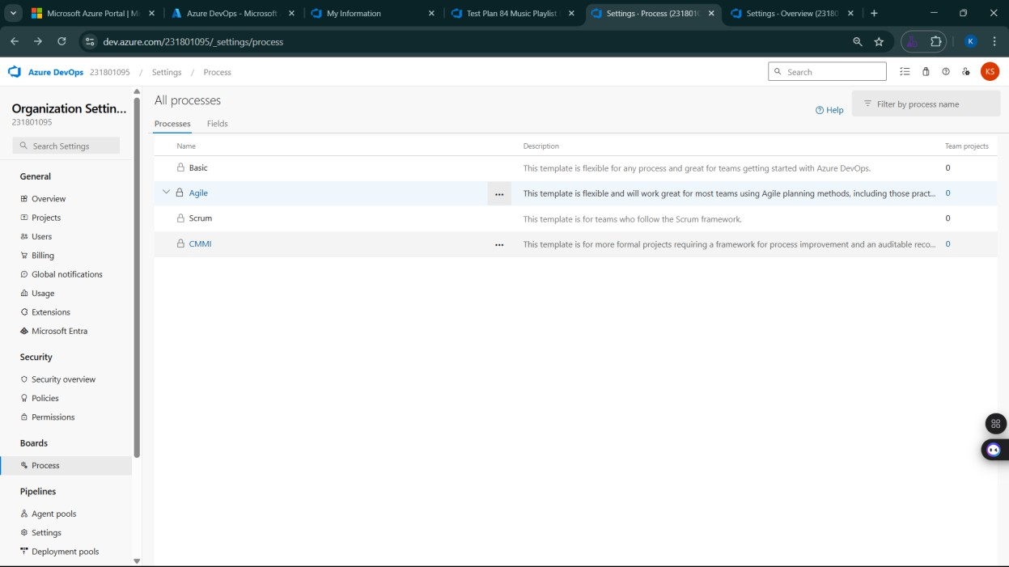
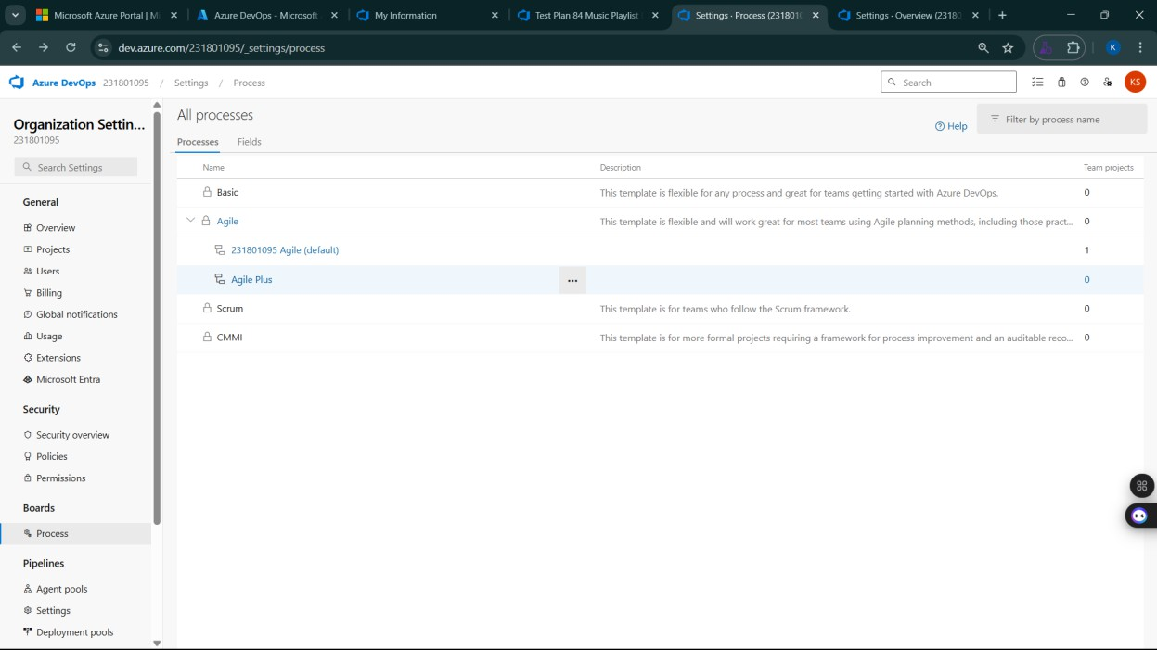

- View the new test case template
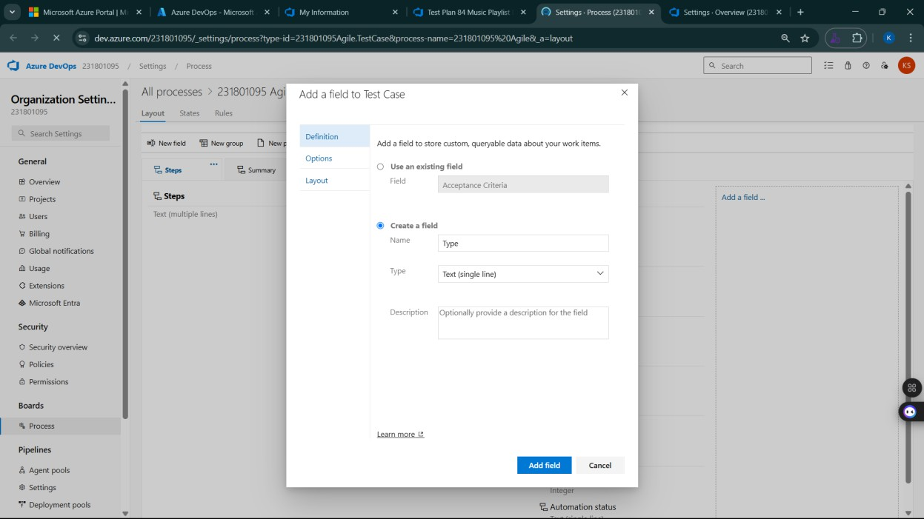

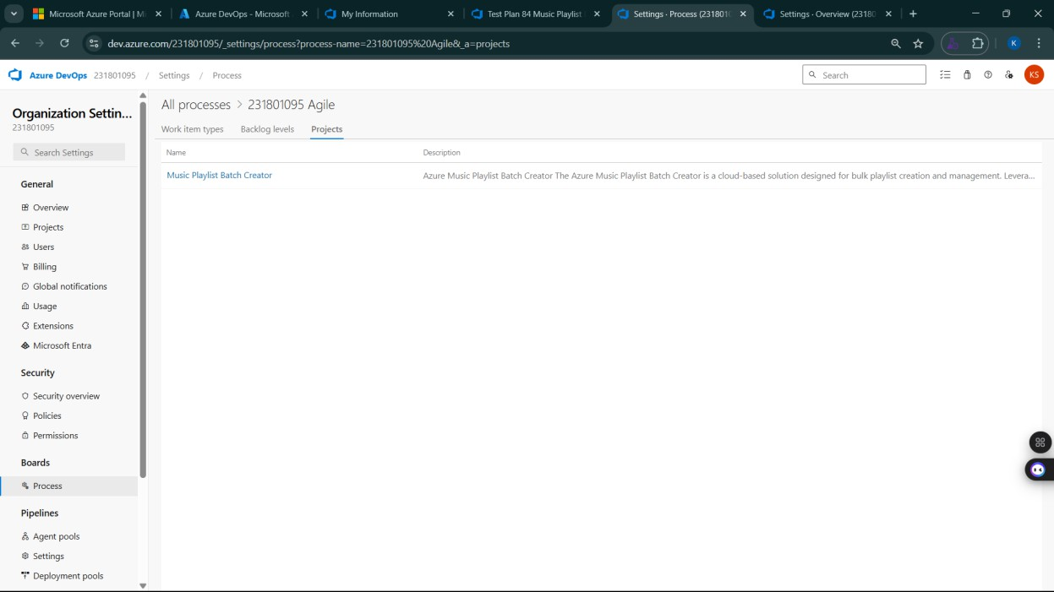

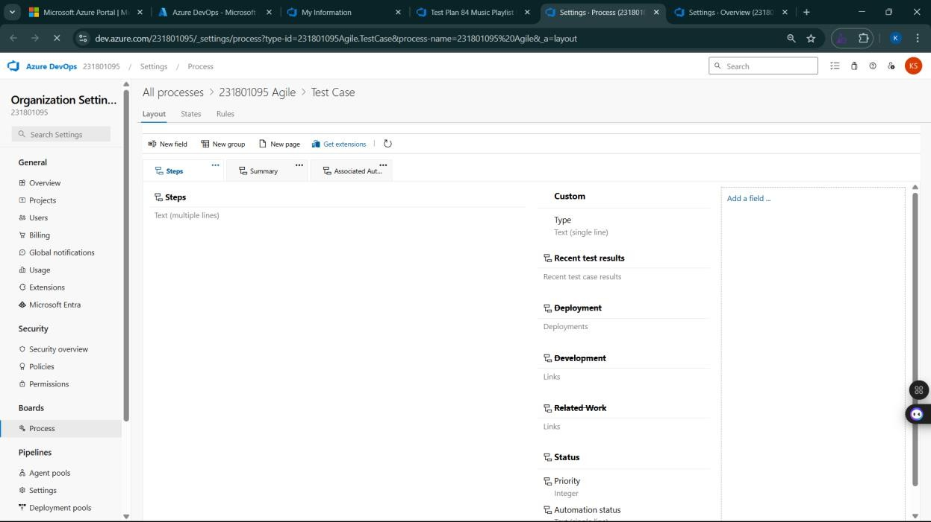

Result:
The test plans and test cases for the user stories is created in Azure DevOps with Happy Path and
Error Path

LOAD TESTING AND PERFORMANCE TESTING

EXP NO: 9

Aim:
Create Epic, Features, User Stories, Task
To create an Azure Load Testing resource and run a load test to evaluate the performance of a target endpoint.

Load Testing

Steps to Create an Azure Load Testing Resource:
Before you run your first test, you need to create the Azure Load Testing resource:
- Sign in to Azure Portal
Go to https://portal.azure.com and log in.
- Create the Resource
  - Go to Create a resource → Search for “Azure Load Testing”.
  - Select Azure Load Testing and click Create.
- Fill in the Configuration Details
  - Subscription: Choose your Azure subscription.
  - Resource Group: Create new or select an existing one.
  - Name: Provide a unique name (no special characters).
  - Location: Choose the region for hosting the resource.
- (Optional) Configure tags for categorization and billing.
- Click Review + Create, then Create.
- Once deployment is complete, click Go to resource.

Steps to Create and Run a Load Test:
Once your resource is ready:
- Go to your Azure Load Testing resource and click Add HTTP requests > Create.
- Basics Tab
  - Test Name: Provide a unique name.
  - Description: (Optional) Add test purpose.
  - Run After Creation: Keep checked.
- Load Settings
  - Test URL: Enter the target endpoint (e.g., https://yourapi.com/products).
- Click Review + Create → Create to start the test.

Load Testing
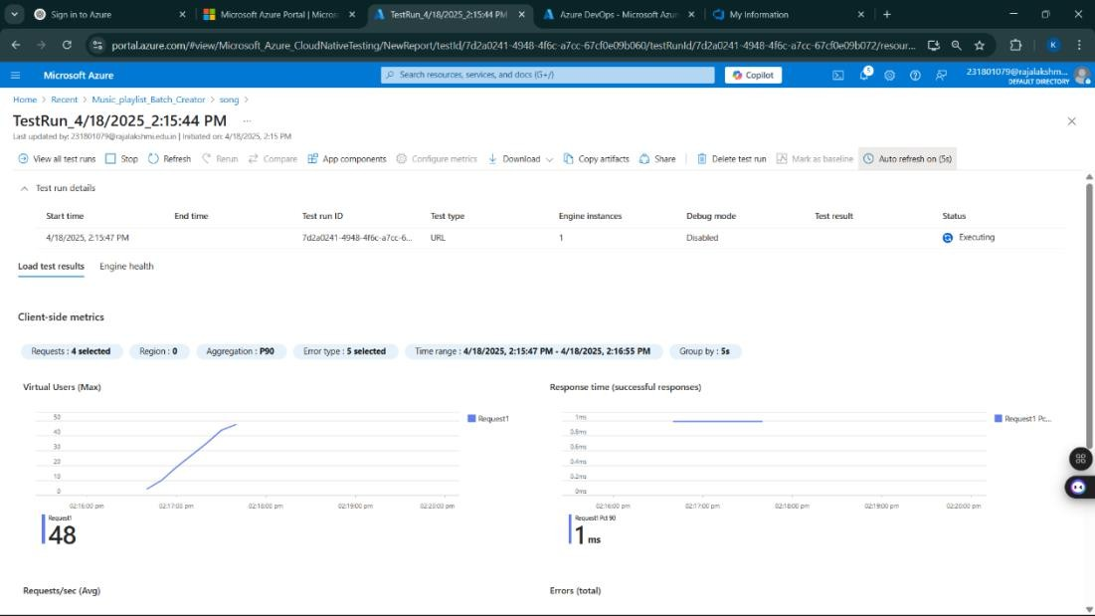

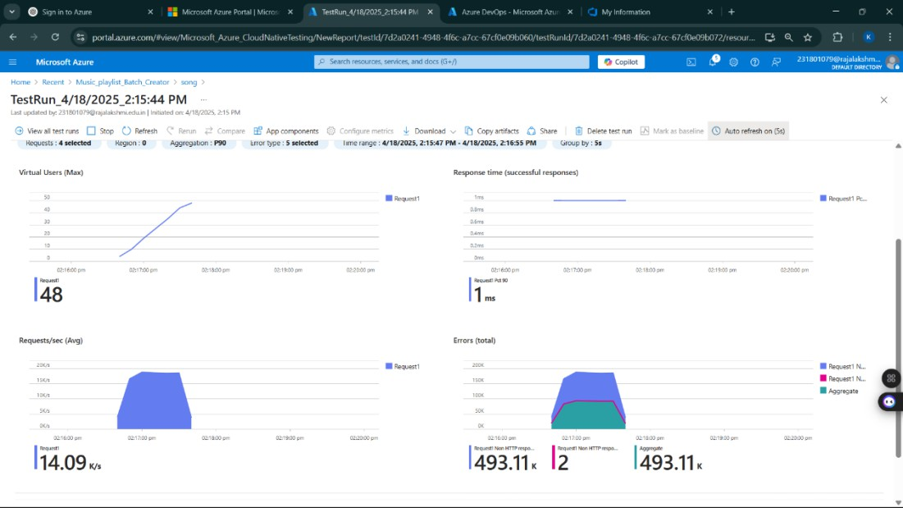

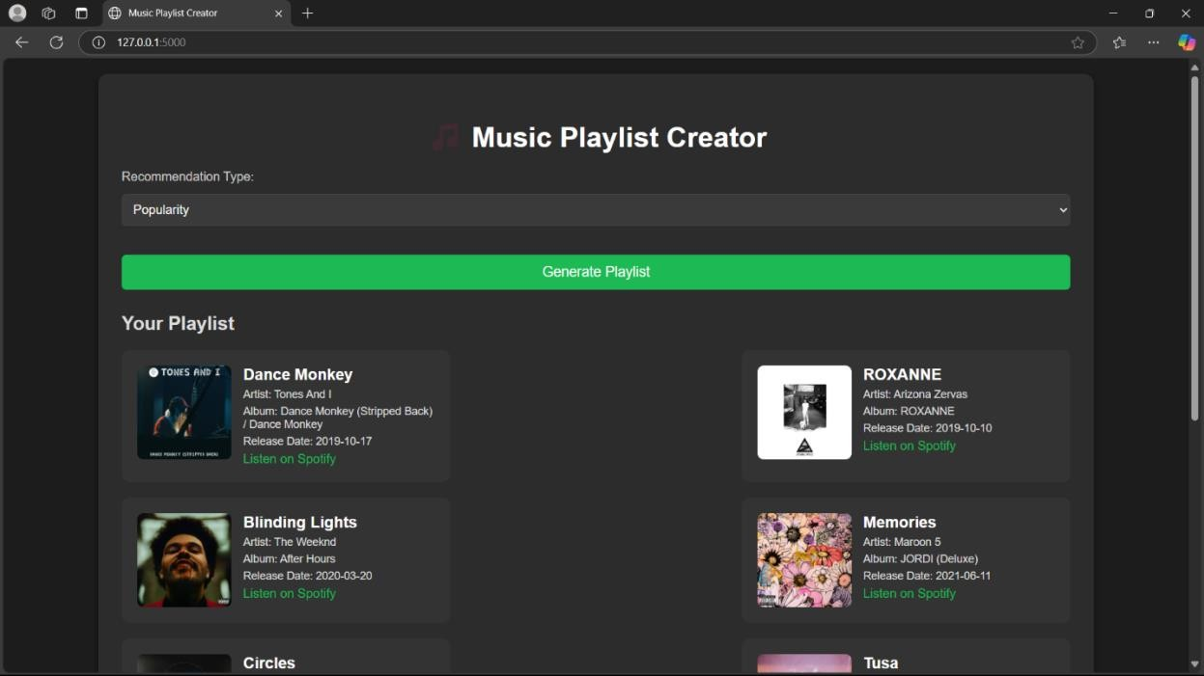

Result:
Successfully created the Azure Load Testing resource and executed a load test to assess the
performance of the specified endpoint.

GITHUB: PROJECT STRUCTURE & NAMING CONVENTIONS

EXP NO: 10

Aim:
Create Epic, Features, User Stories, Task
To provide a clear and organized view of the project's folder structure and file naming conventions, helping contributors and users easily understand, navigate, and extend the Music Playlist Batch Creator project.

GitHub Project Structure
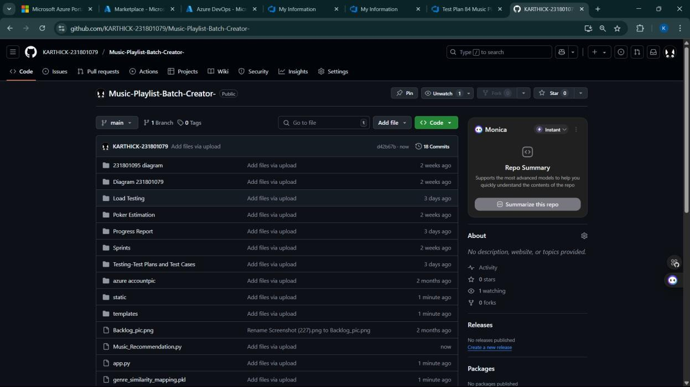

Result:
The GitHub repository clearly displays the organized project structure and consistent naming
conventions, making it easy for users and contributors to understand and navigate the codebase.

